**LAB CYCLE1**

**Anunadh Rajesh**

**20MCA015**

**S2MCA**

# Q UESTION SET 1

1. Create an employee table ‘EMP’ with following fields :

empno NUMBER(2)

ename VARCHAR2(25)

job VARCHAR2(12)

salary NUMBER(10,2)

commission NUMBER(7,2)

deptno NUMBER(2)

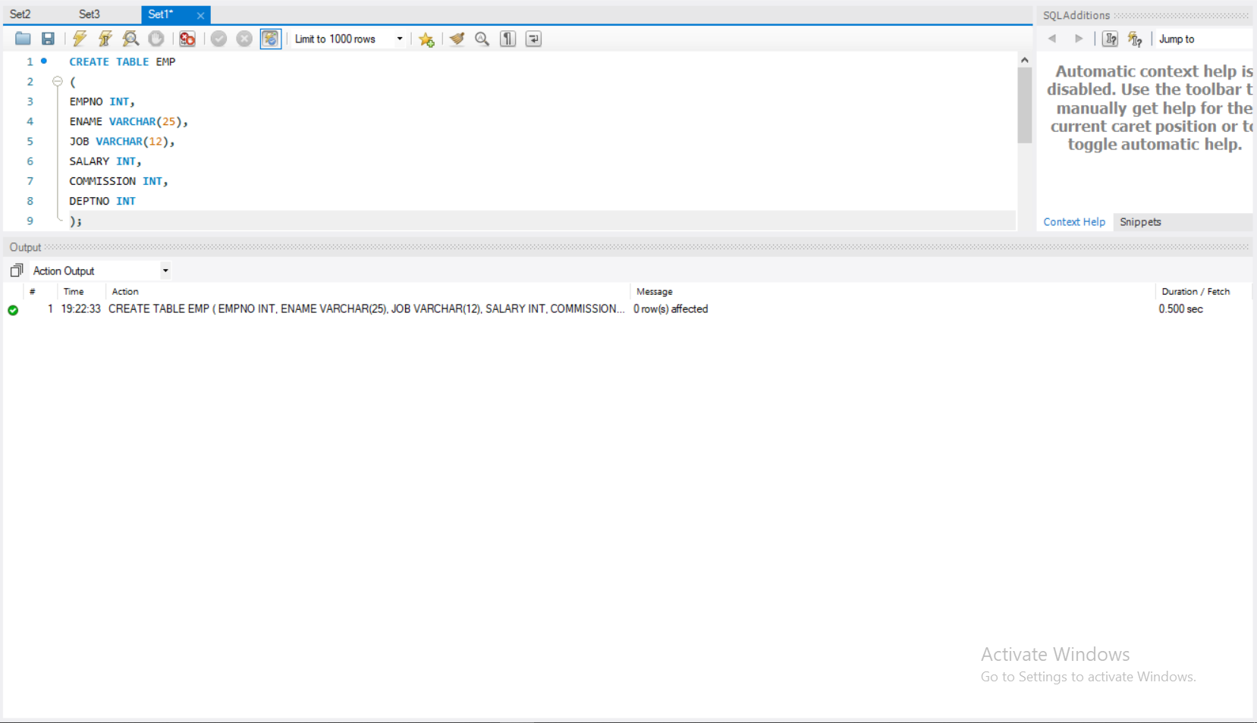

1. Display the structure of ‘EMP’

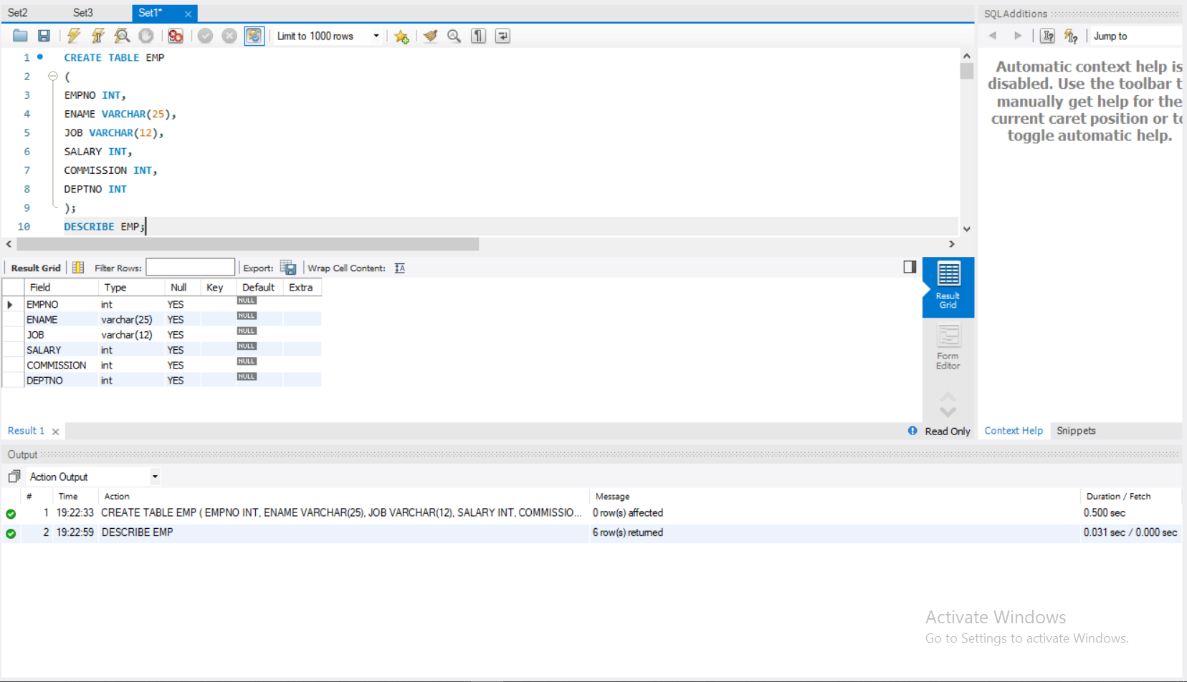

1. Insert the following record into ‘EMP’

|  |  |  |  |  |
| --- | --- | --- | --- | --- |
| **EMPNO ENAME** | **JOB** | **SAL** | **COMM** | **DEPTNO** |
| 7369 SMITH | CLERK | 800 |  | 20 |
|  |  |  |  |  |

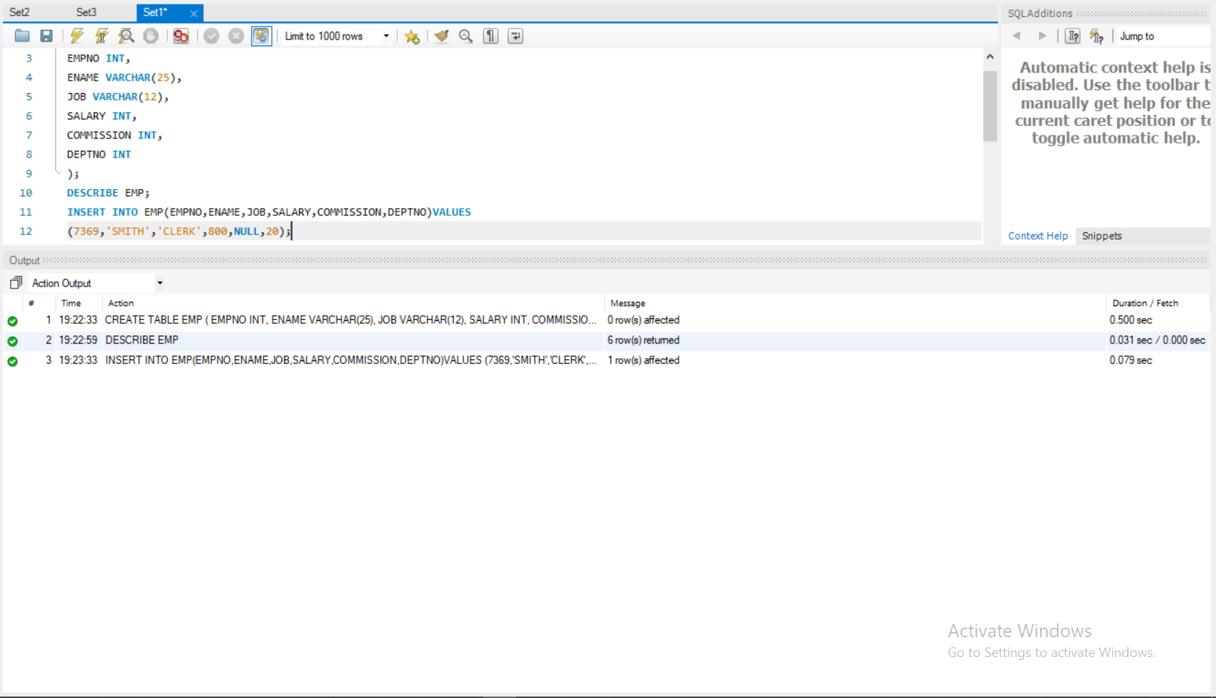

1. Insert the rest of records using substitution variable.

|  |  |  |  |  |  |
| --- | --- | --- | --- | --- | --- |
| **EMPNO** | **ENAME** | **JOB** | **SAL** | **COMM** | **DEPTNO** |
| 7499 | ALLEN | SALESMAN | 1600 | 300 | 30 |
| 7521 | WARD | SALESMAN | 1250 | 500 | 30 |
| 7566 | JONES | MANAGER | 2975 |  | 20 |
| 7654 | MARTIN | SALESMAN | 1250 | 1400 | 30 |
| 7698 | BLAKE | MANAGER | 2850 |  | 30 |
| 7782 | CLARK | MANAGER | 2450 |  | 10 |
| 7788 | SCOTT | ANALYST | 3000 |  | 20 |
| 7839 | KING | PRESIDENT | 5000 |  | 10 |
| 7844 | TURNER | SALESMAN | 1500 |  | 30 |
| 7876 | ADAMS | CLERK | 1100 |  | 20 |
| 7900 JAMES | | NULL | 950 | 30 | |
| 7902 FORD | | ANALYST | 3000 | 20 | |
| 7934 MILLER | | CLERK | 1300 | 10 | |

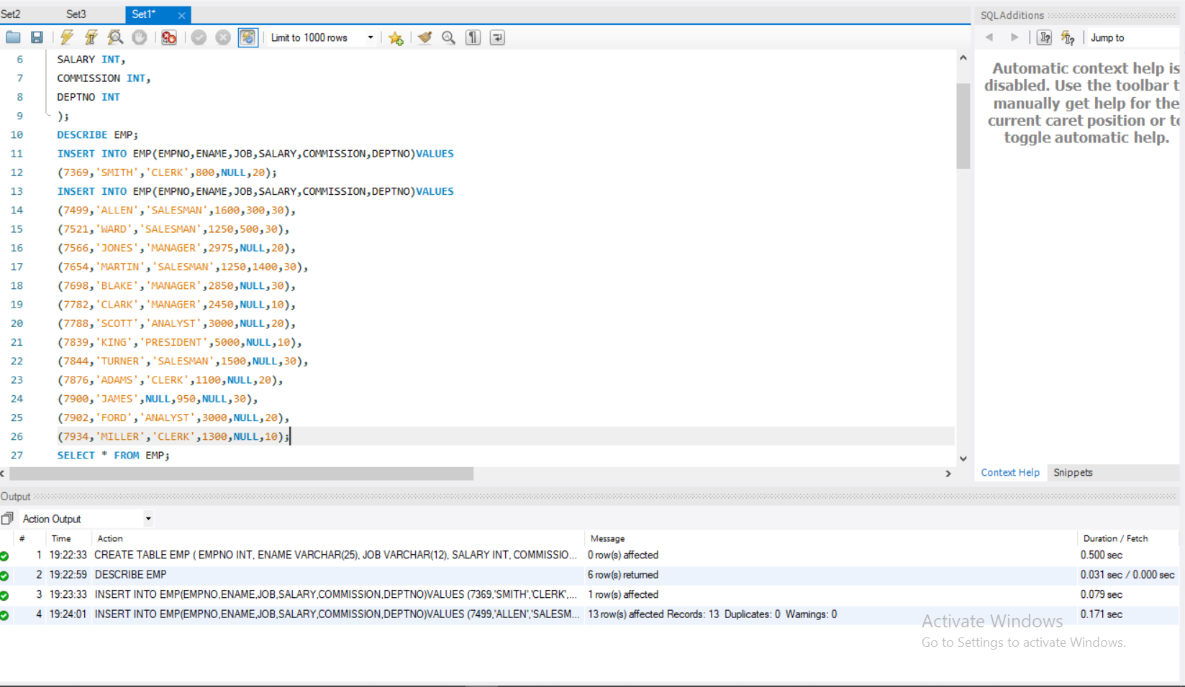

1. Insert job as ‘CLERK’ for all ‘NULL’ job types.

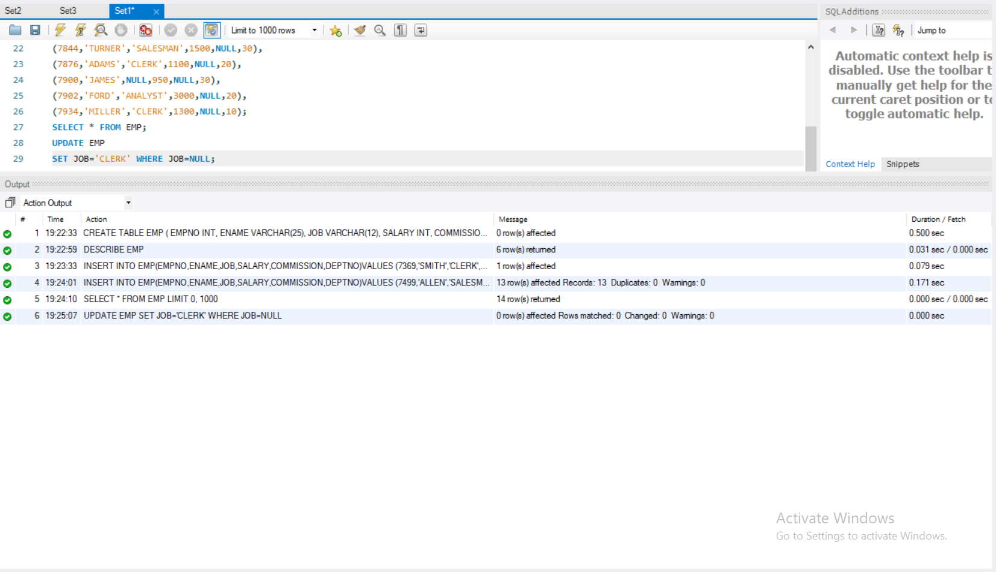

1. Add a new field ‘date_join’ with following values

**date_join**

17-DEC-80

20-FEB-81

22-FEB-81

02-APR-81

28-SEP-81

01-MAY-81

09-JUN-81

19-APR-87

17-NOV-81

08-SEP-81

23-MAY-87

03-DEC-81

03-DEC-81

23-JAN-82

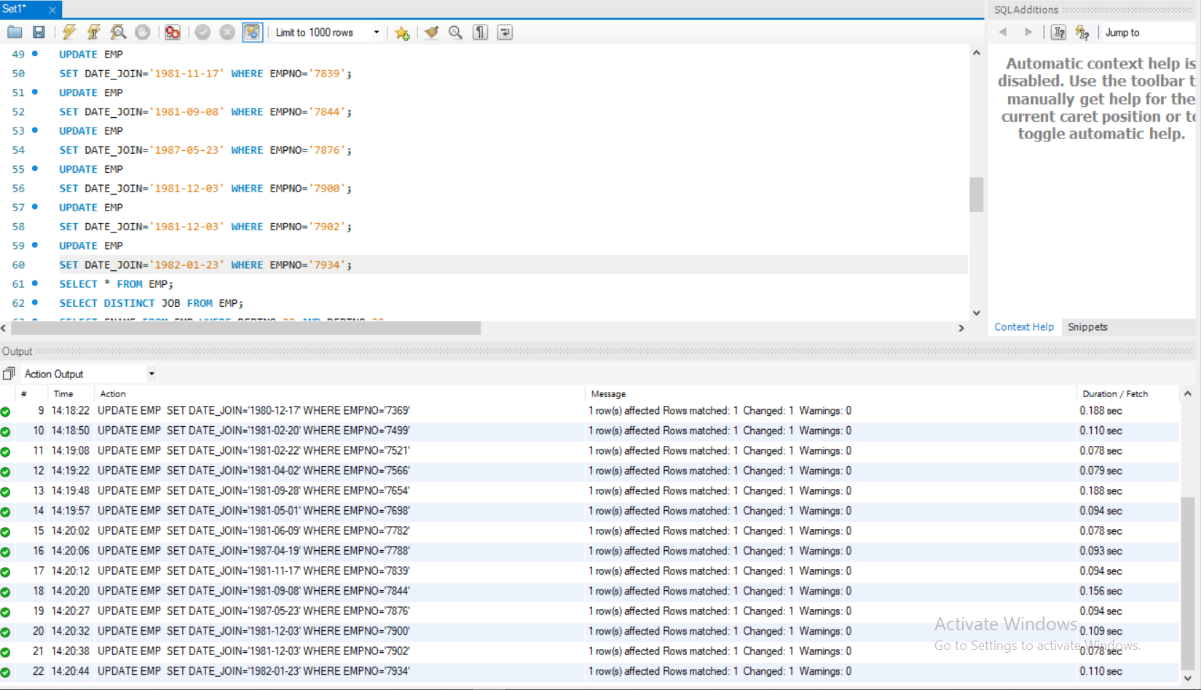

1. Display details of all employees

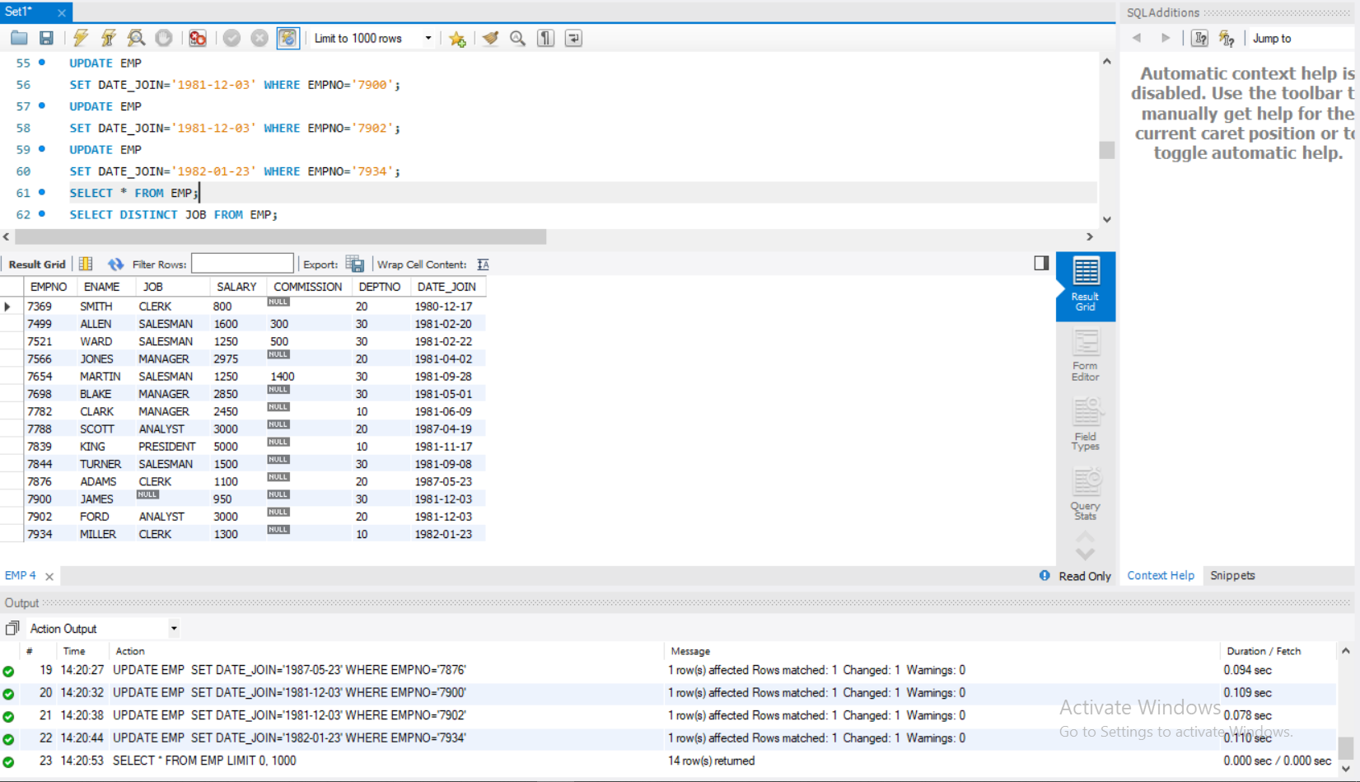

1. Display all the distinct job types in ‘EMP’.

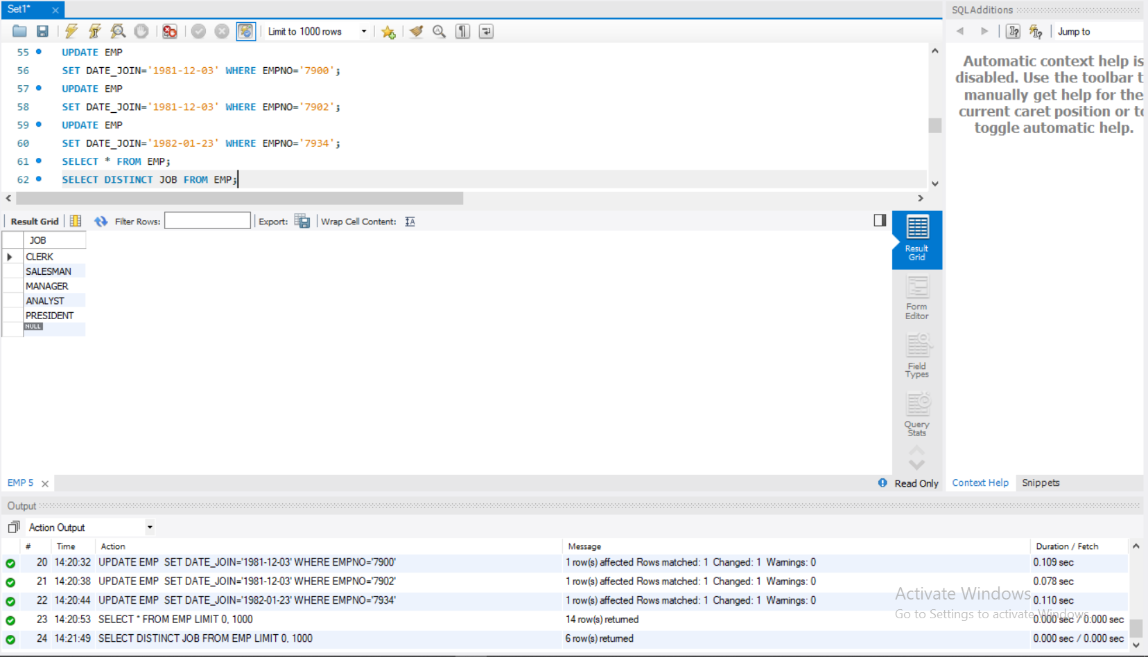

8.

9.Display names of all employees in dept 20 and 30

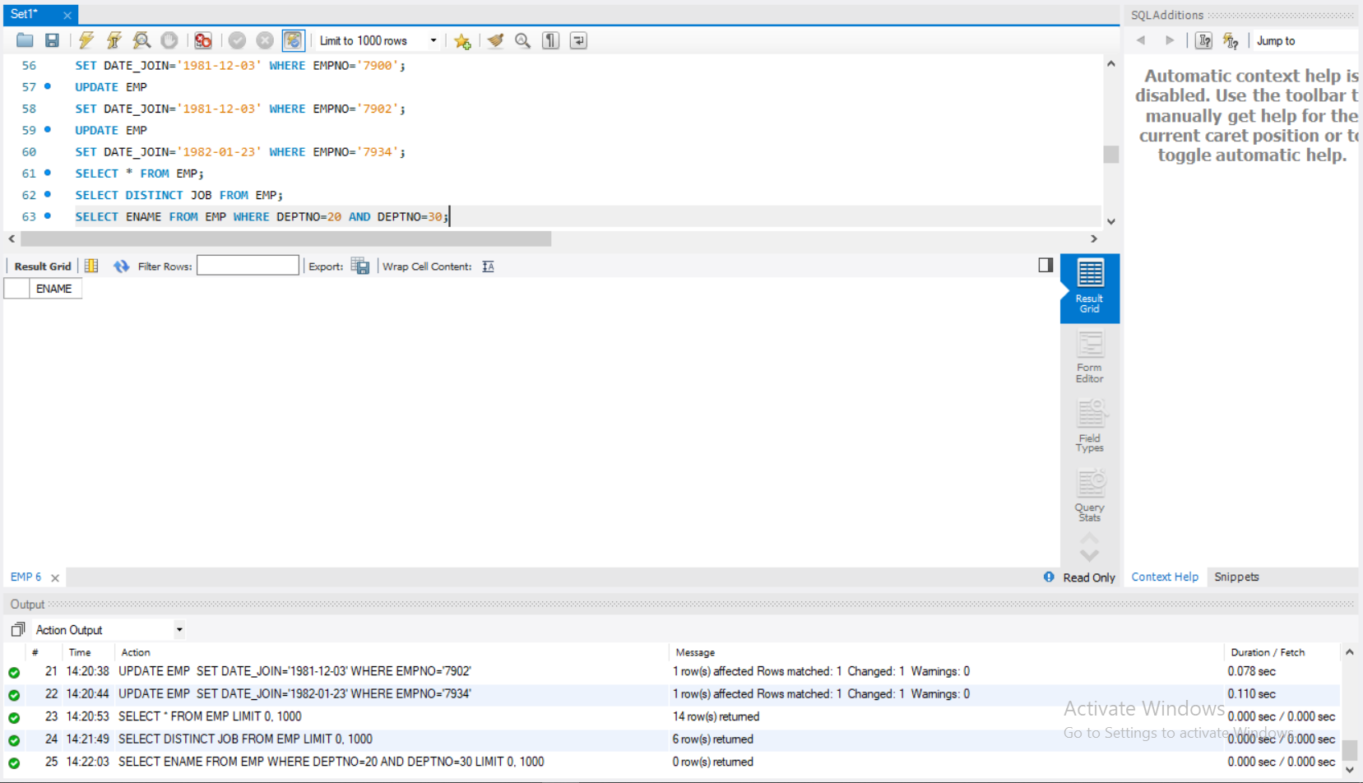

10.List name and Total of salary i.e sal+commission

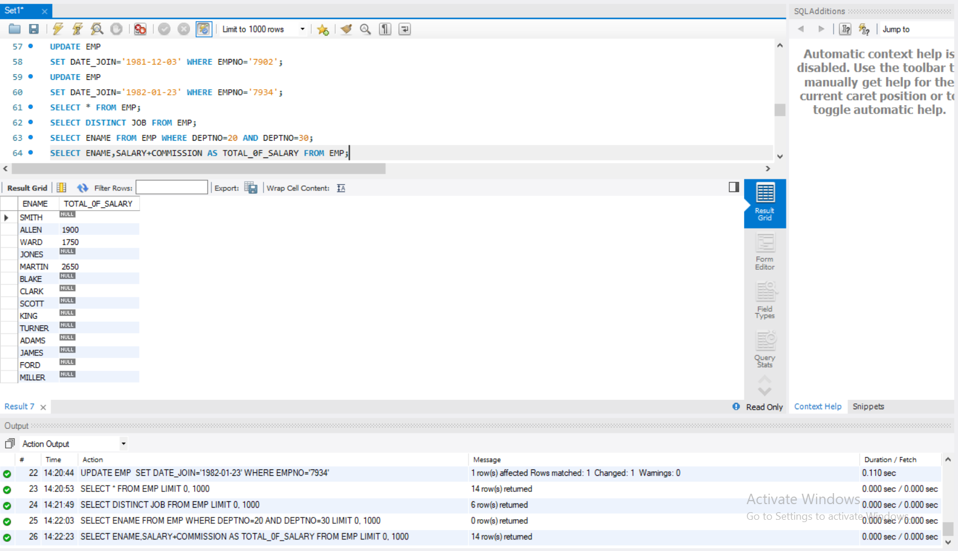

11.List name and Annual Salary i.e sal*12

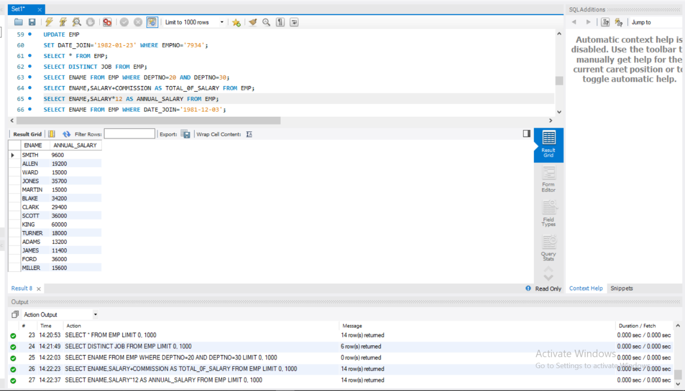

12.List the employee who joined in the date ‘03-DEC-81’

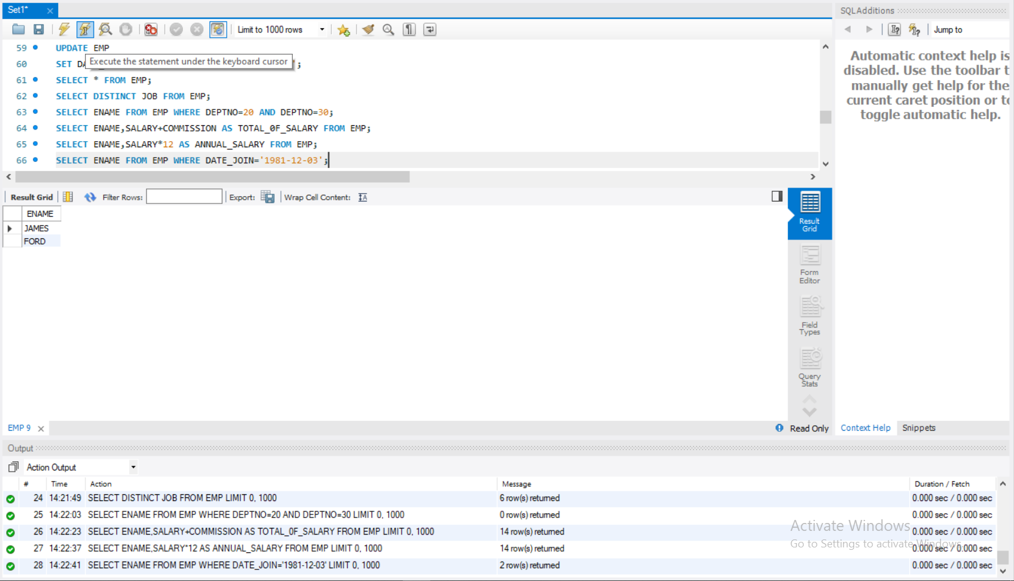

13.Display the total salary of ‘Miller’

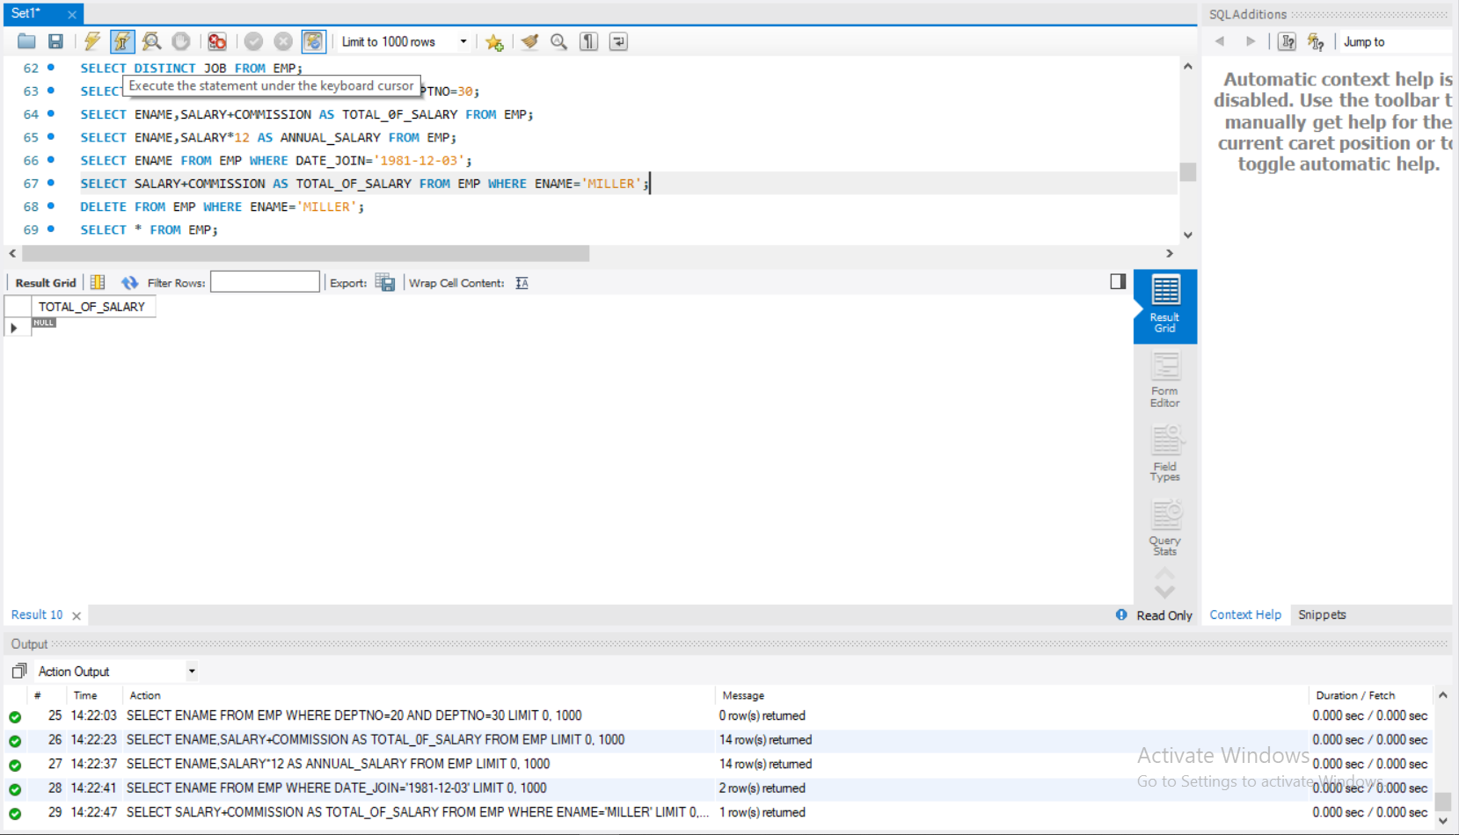

14.Delete the employee ‘Miller’ from’EMP’

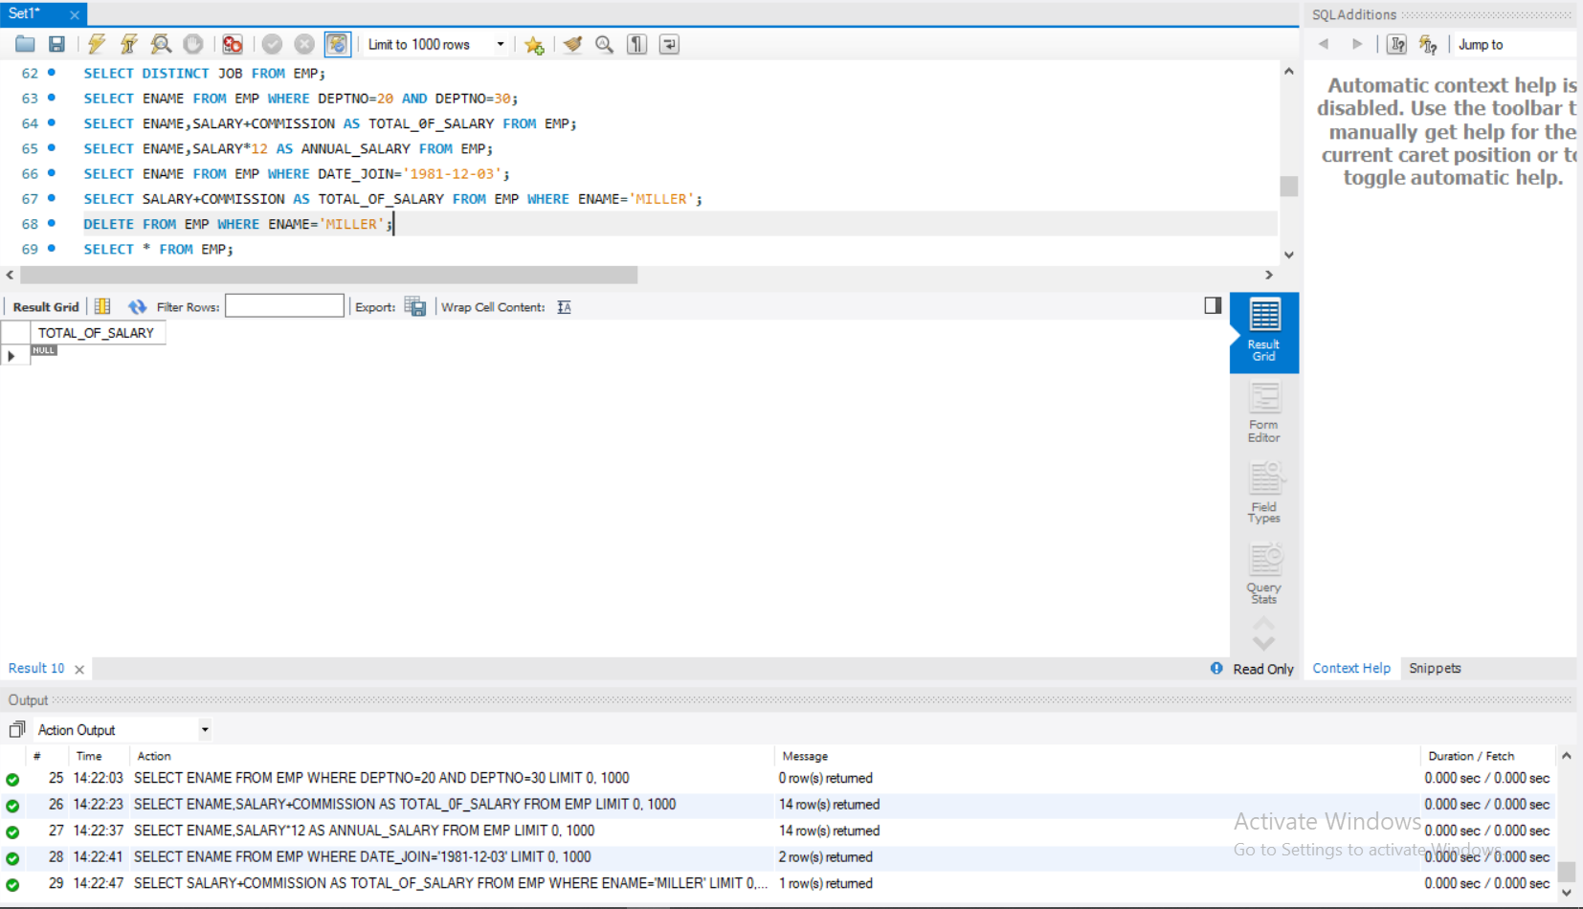

15.Display name and deptno of all employees.

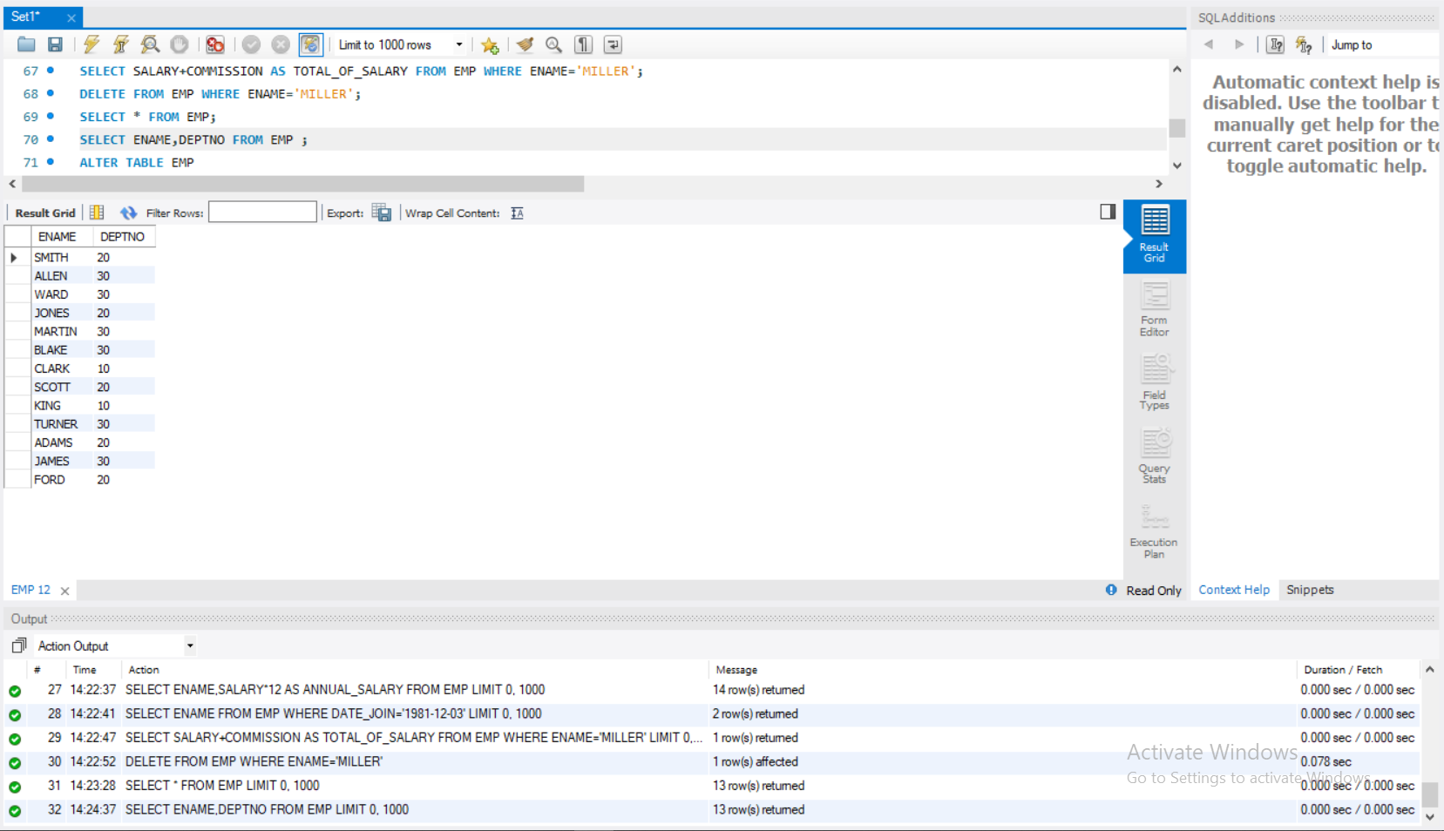

16.Remove the field ‘commission’ fom’EMP’ after updating salary with total salary, i.e sal+commission

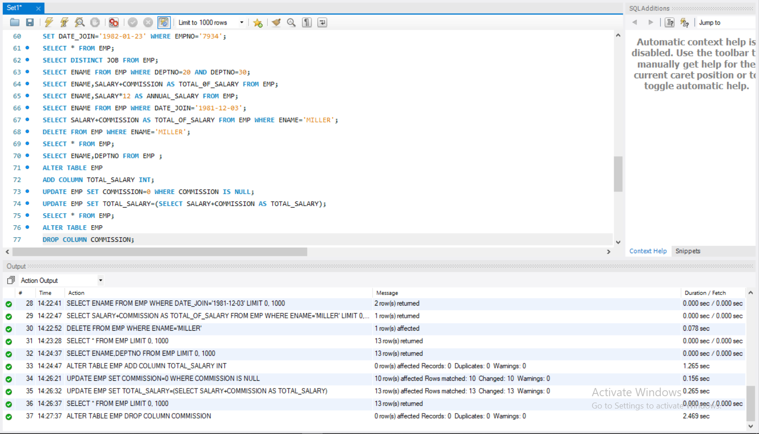

17.Display the name of employees having the same amount of salary **( don’t use subqueries**)

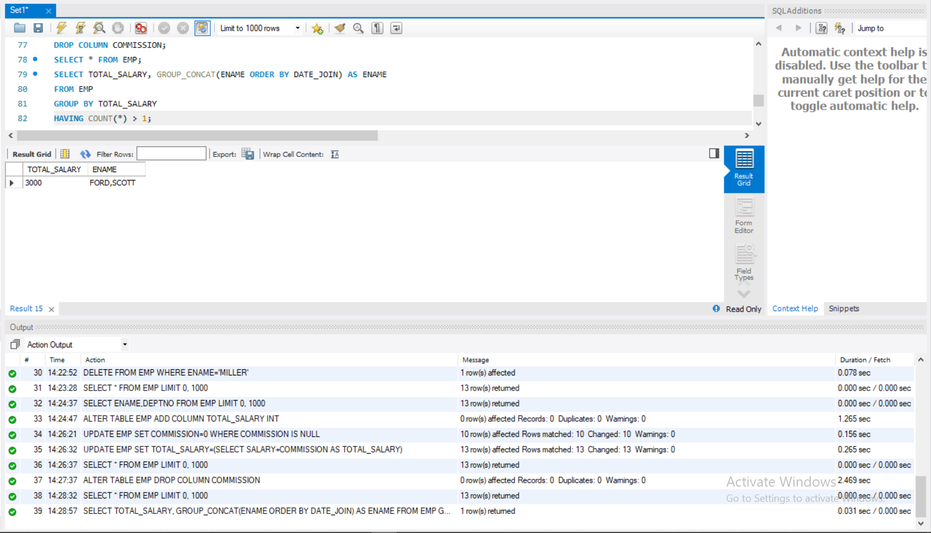

18.Display the name and employee no as ‘name’ and ‘emp_id’

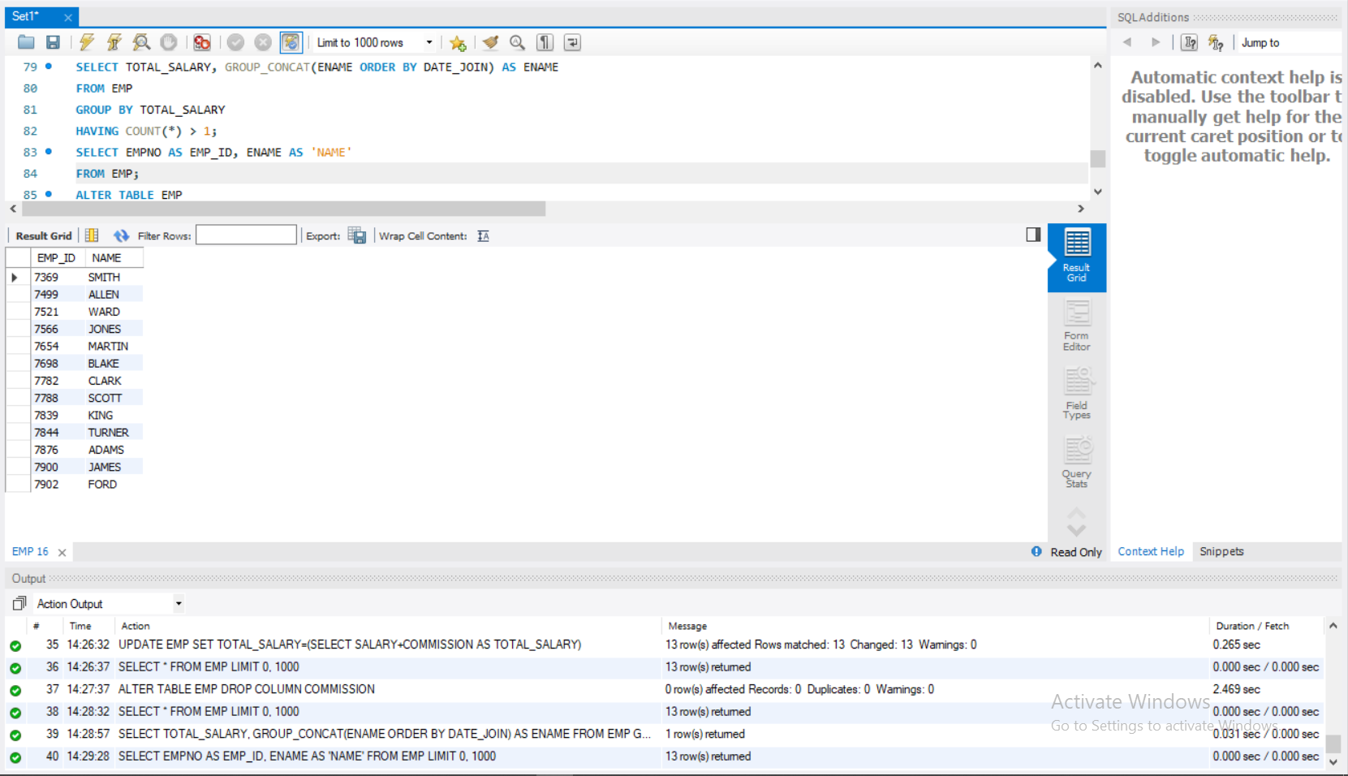

19.Rename table ‘EMP’ to ‘EMPLOYEE’

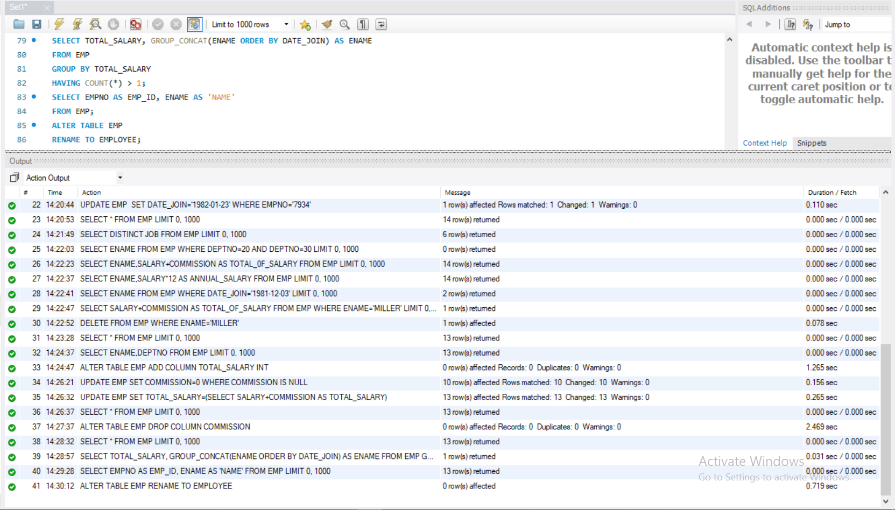

20.Create a new table ‘EMP_TAB’ from table ‘EMPLOYEE’

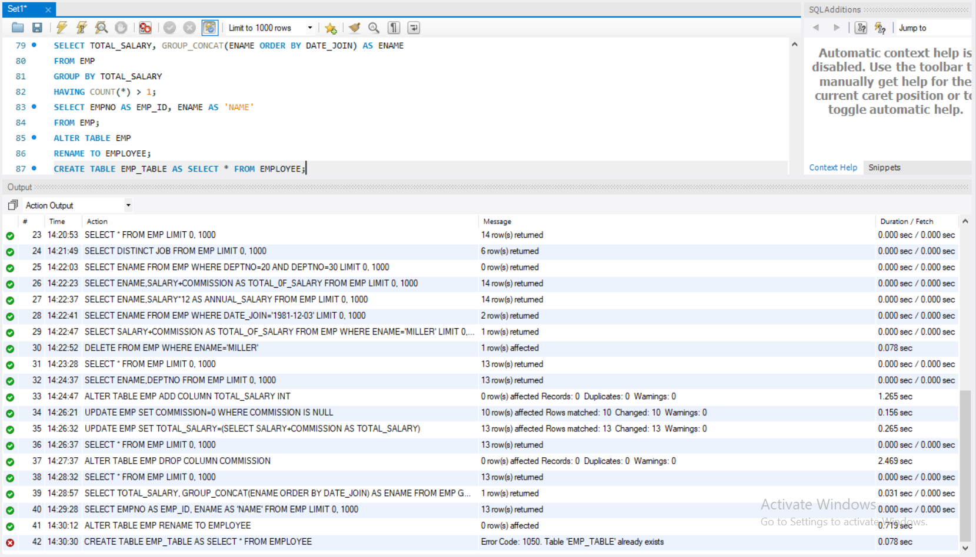

21.List all the details of ‘EMPLOYEE’ and ‘EMP_TAB’

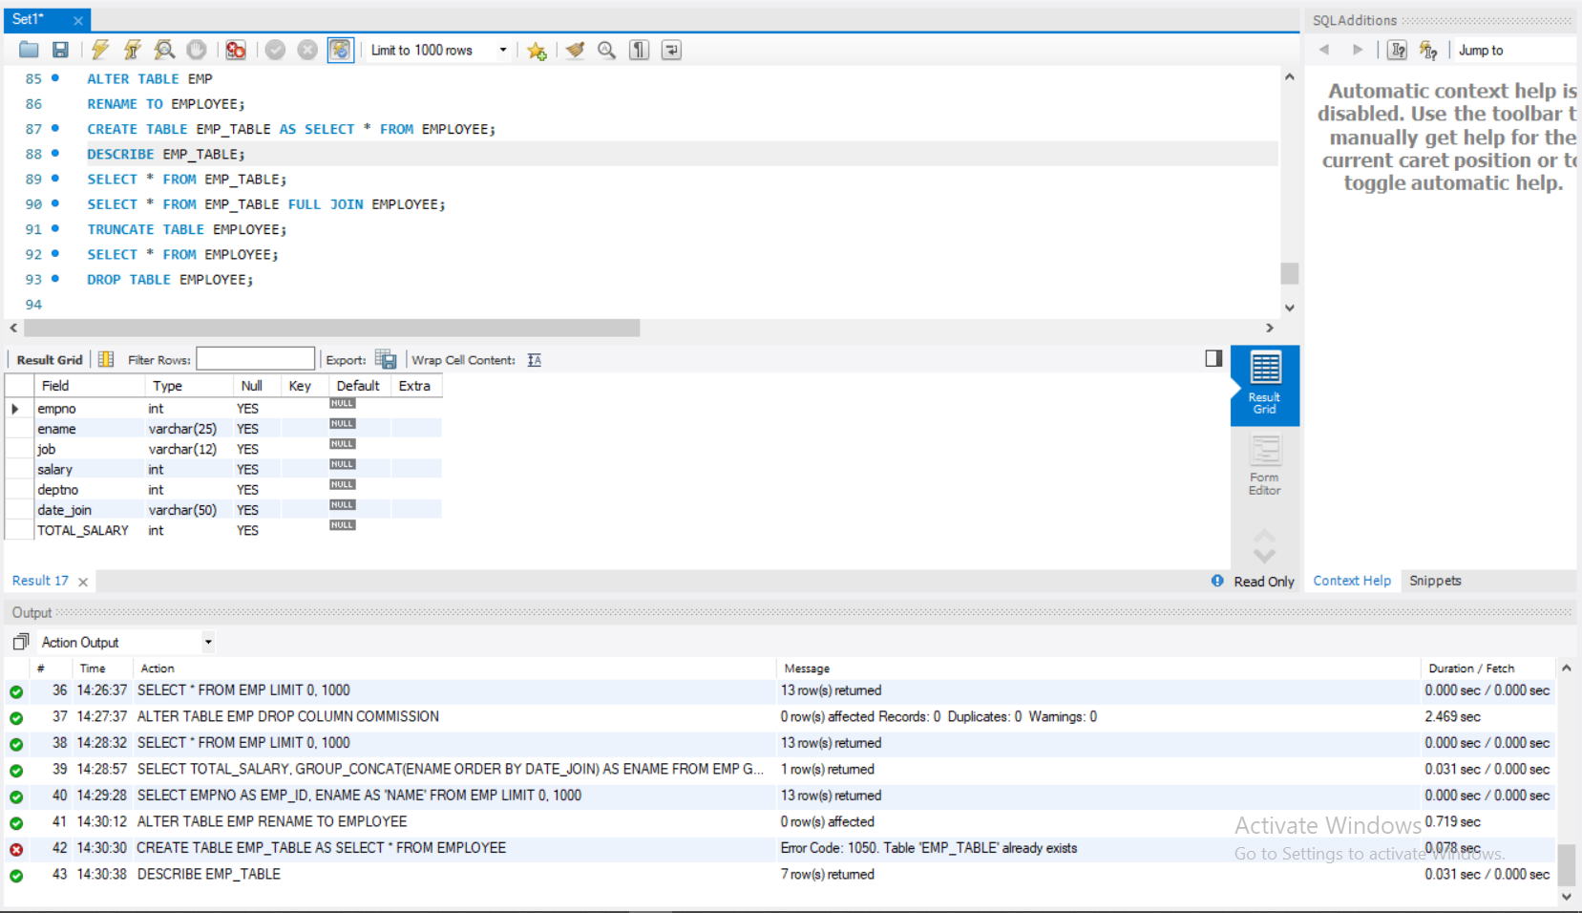

22.Delete all records from ‘EMP’

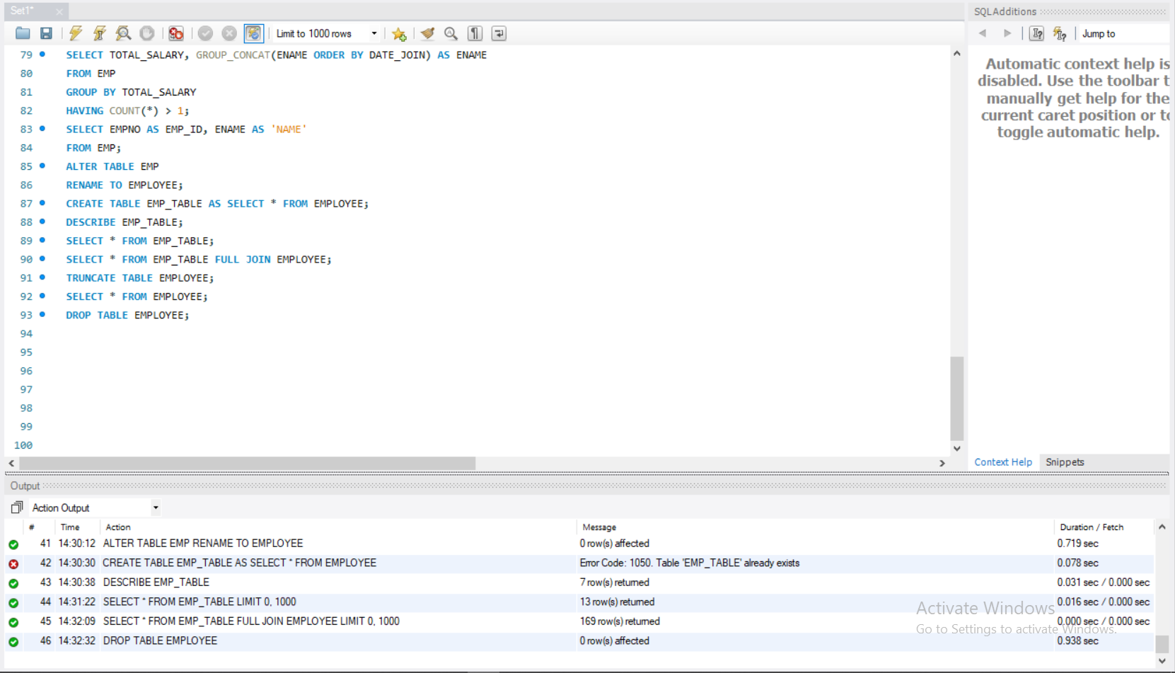

23.Delete the table ‘EMP’



# Q UESTION SET 2

Create a table STUDENT with fields sid, name, dob (date of birth) and marks of 3 subjects ( physics, chemistry and maths ). Add the details of 5 students.

Perform the following queries:

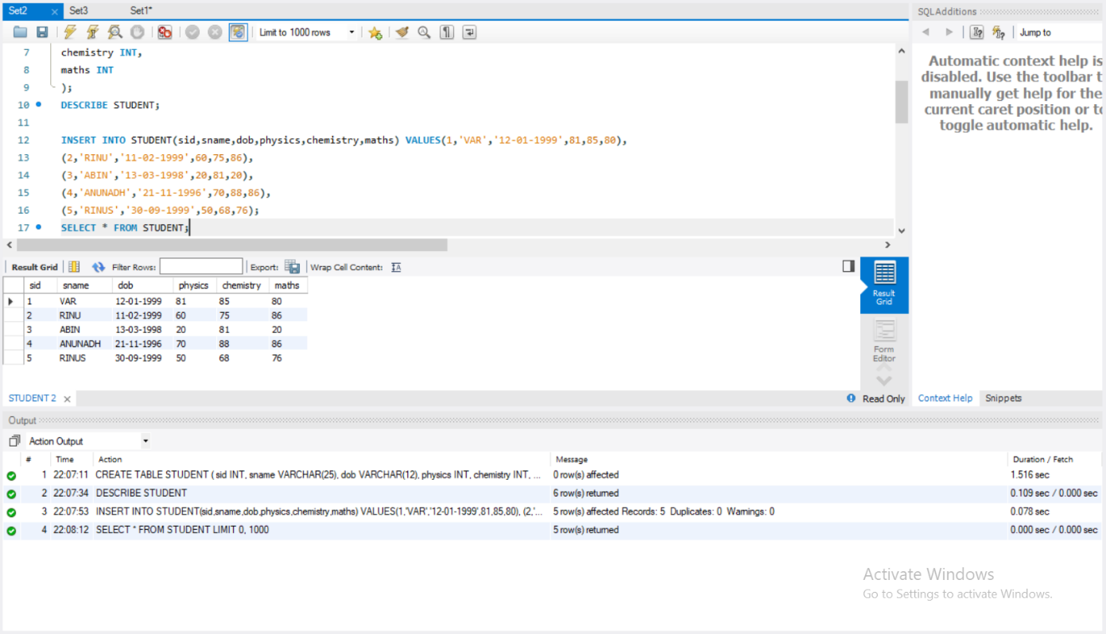

1. Display the id and name of youngest student.

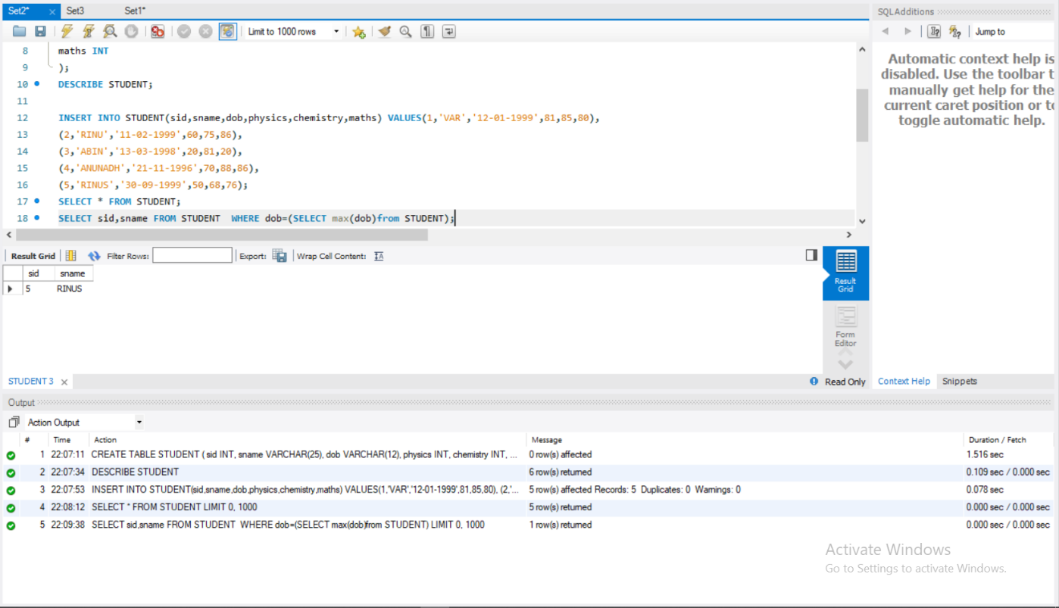

1. Display the details of students who have passed in maths and either in physics or chemistry.(pass mark = 40 marks and above)

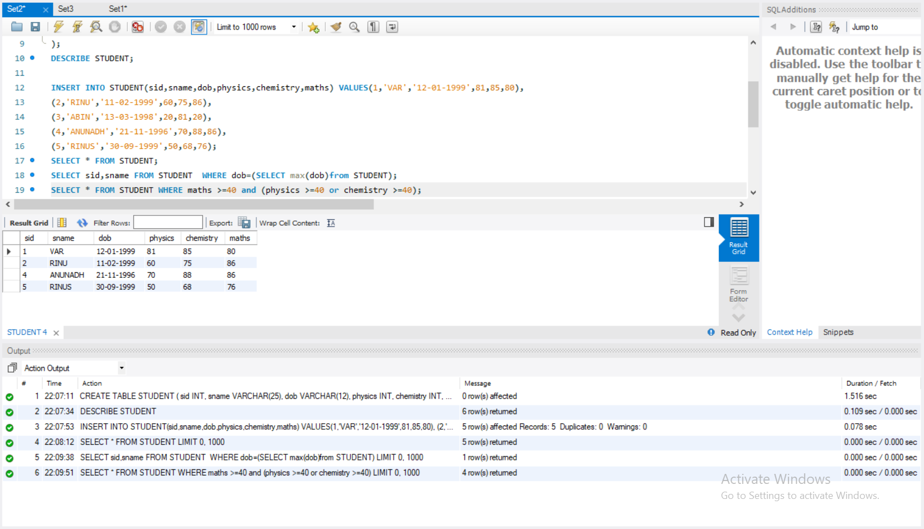

1. Add two more columns total and average.

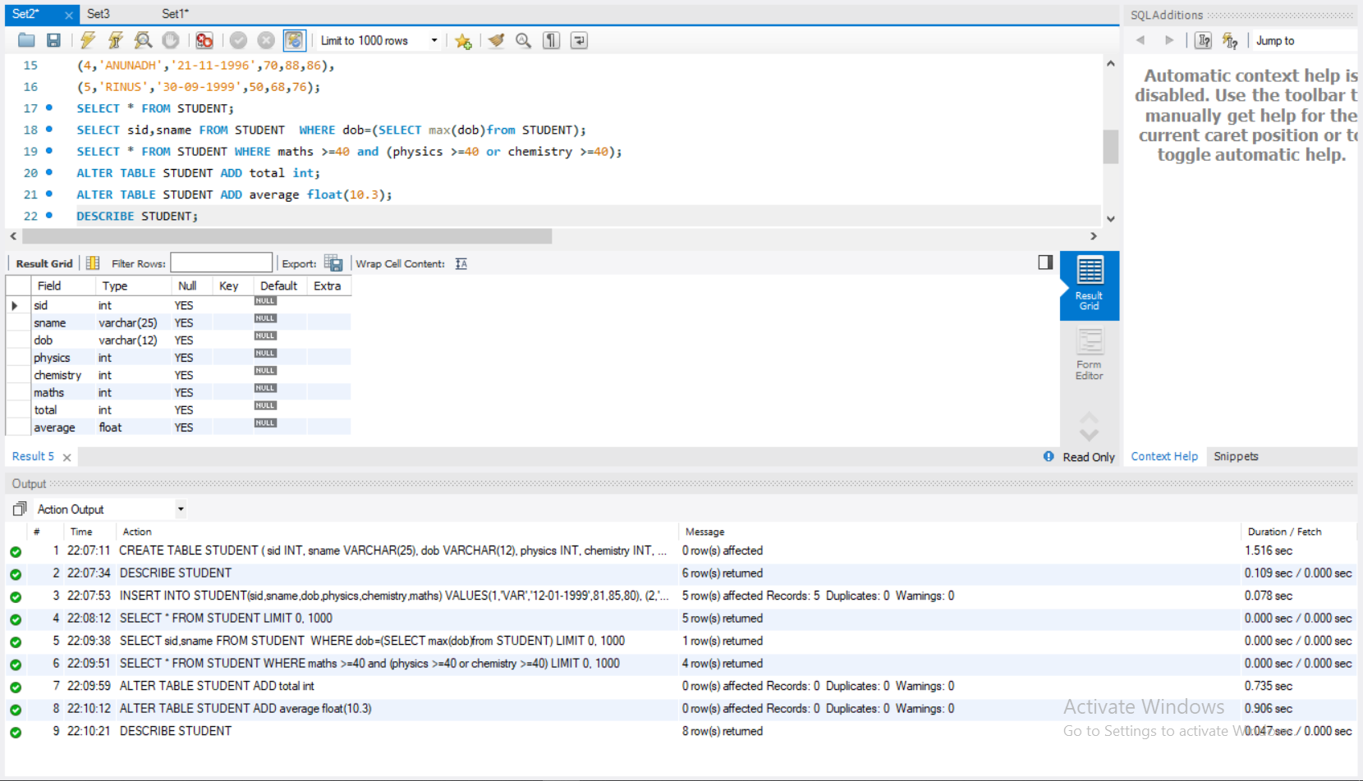

1. Display the name of student who scored highest marks in maths.

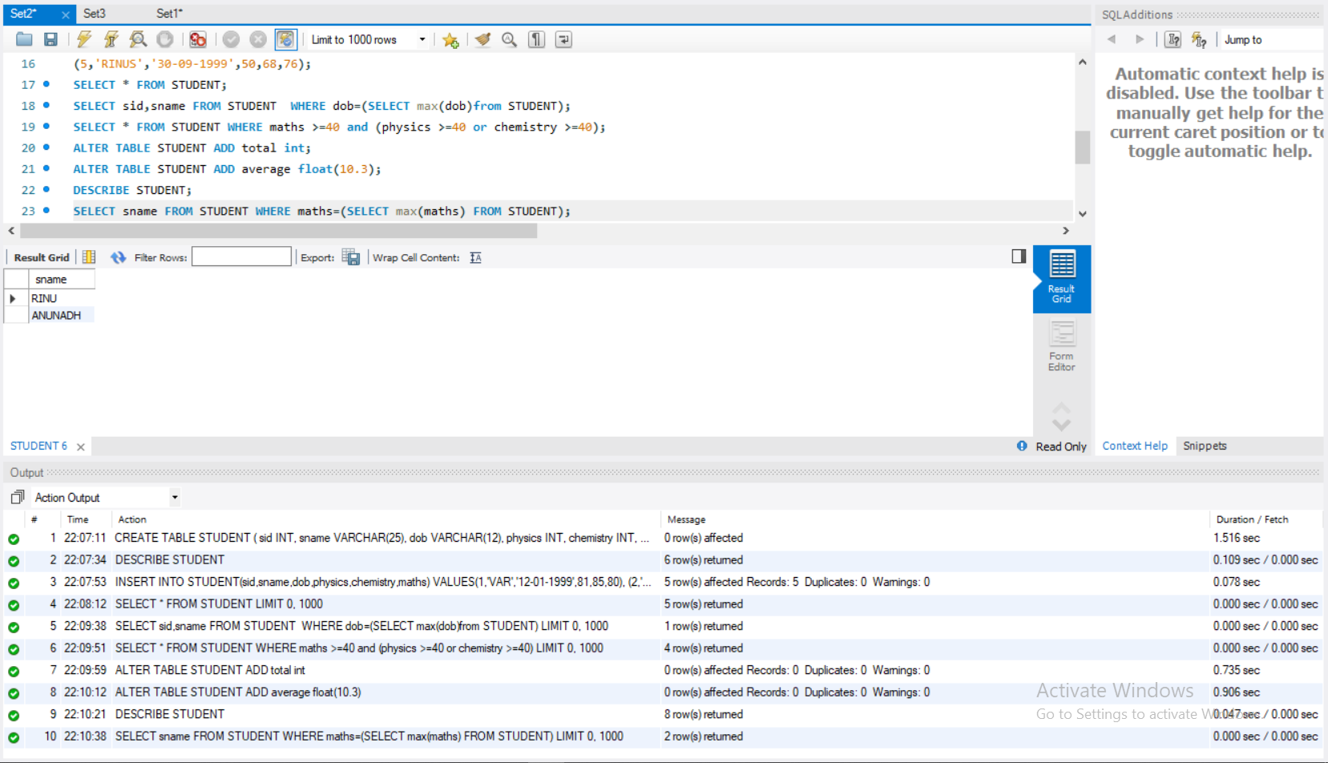

1. Display the name of student who scored least marks in chemistry.

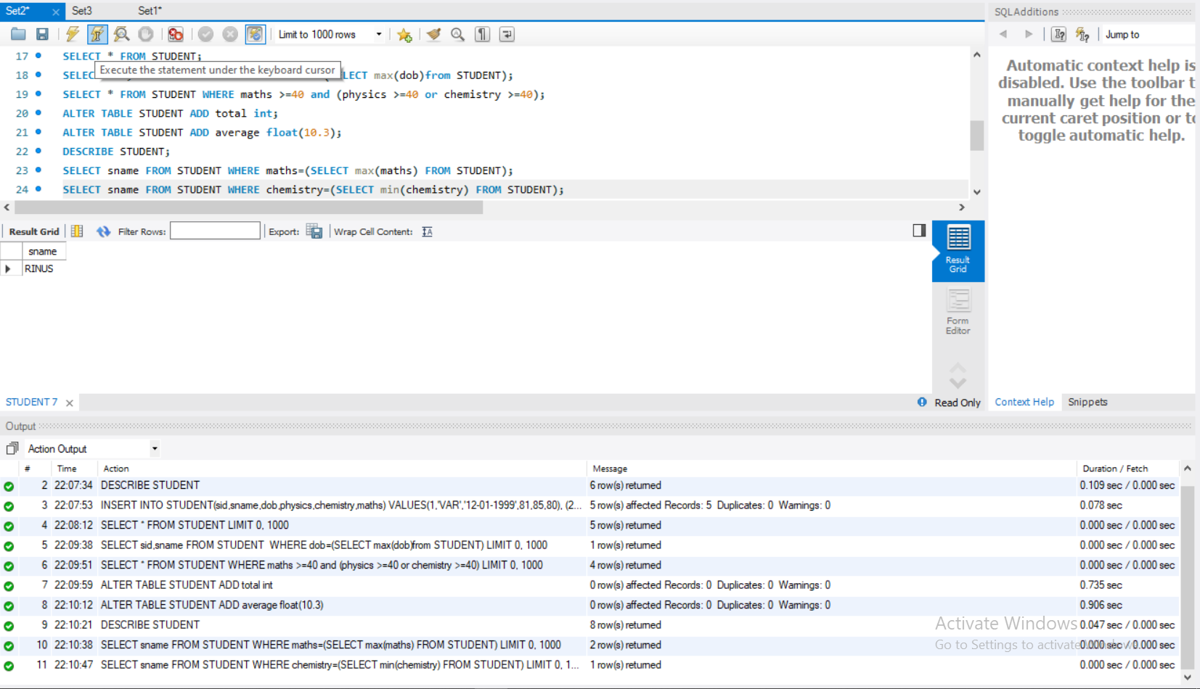

1. Update column total with total marks.

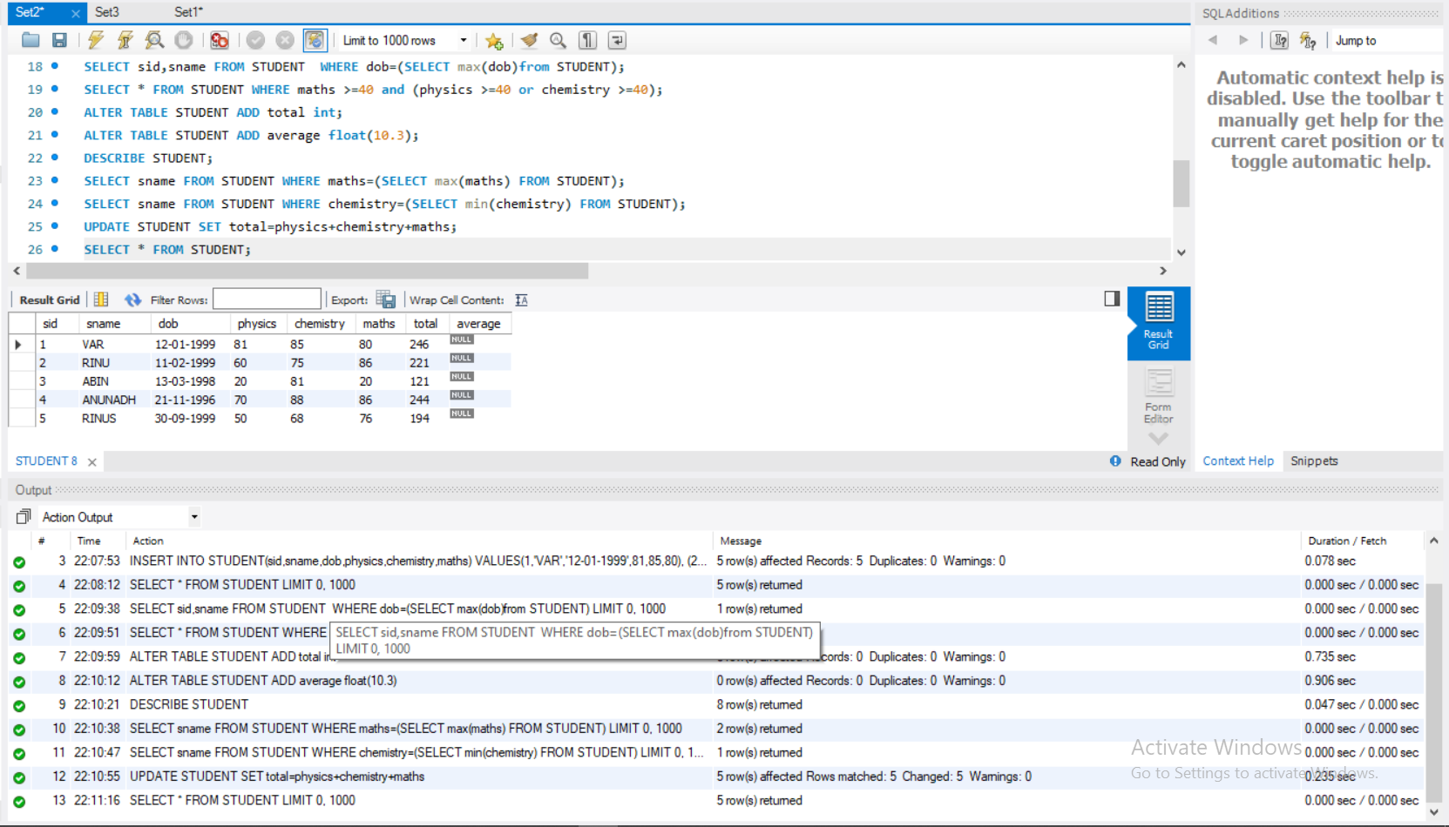

1. Display details of students in order of total merit.

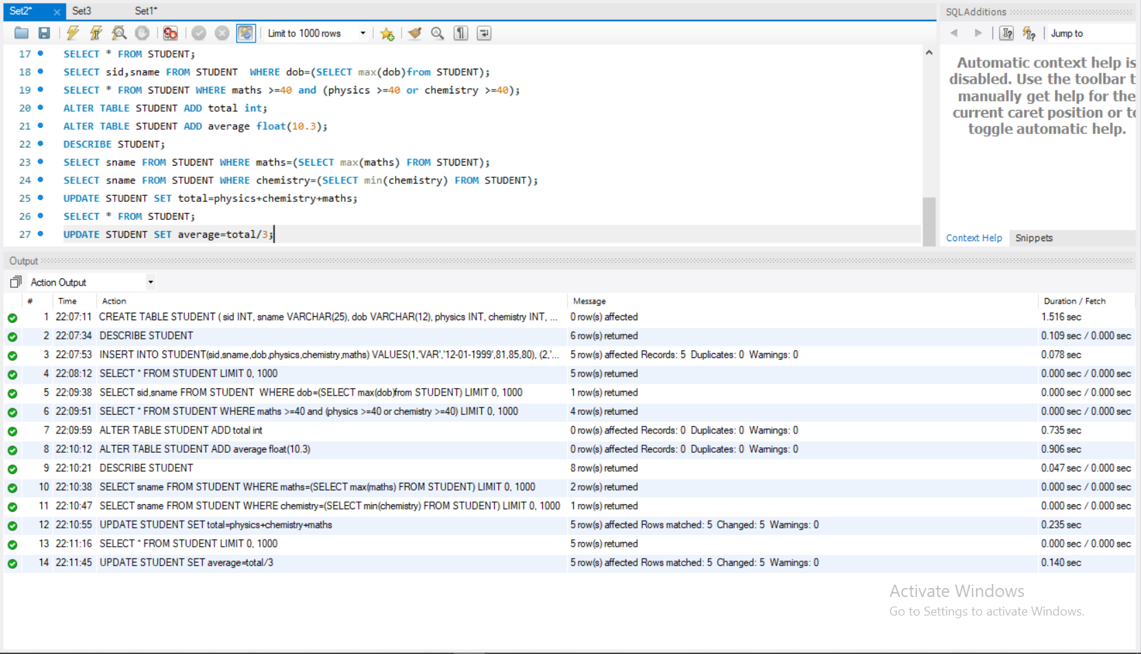

1. Rename the column average with avg mark

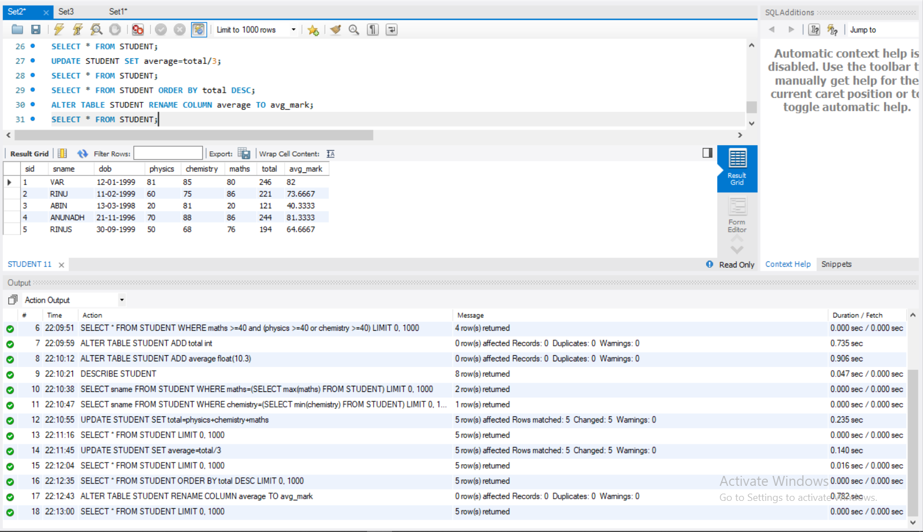

1. Find out the overall average of class.

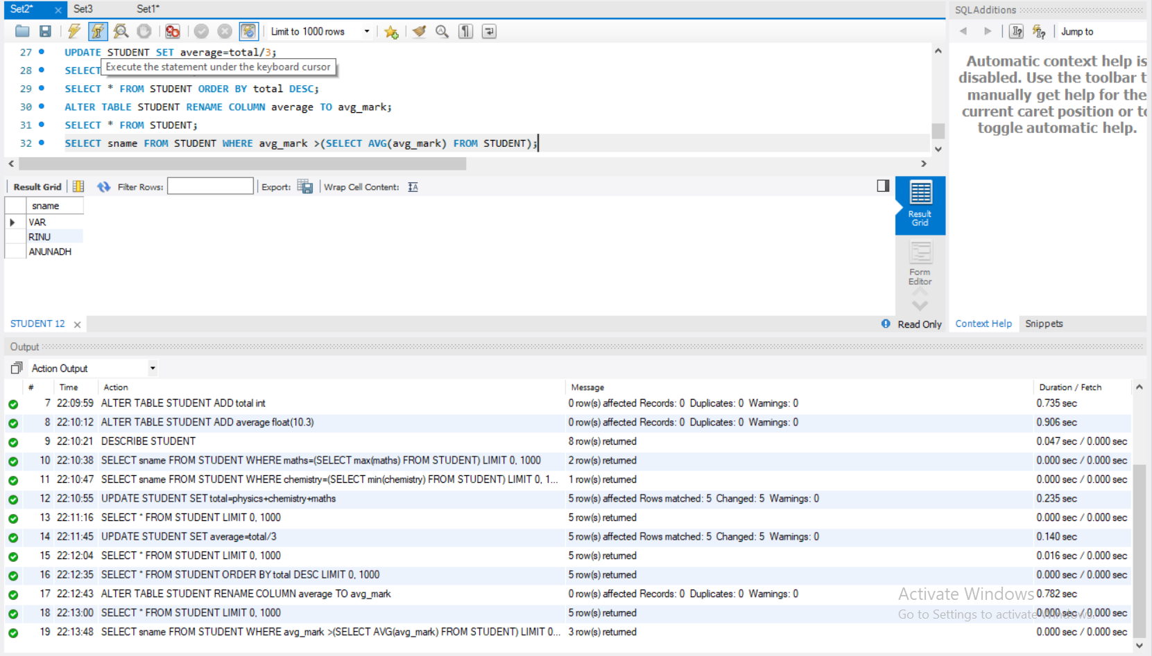

1. Display details of students whose average is greater than overall average.



11.Find the total no: of students whose average is greater than overall average.

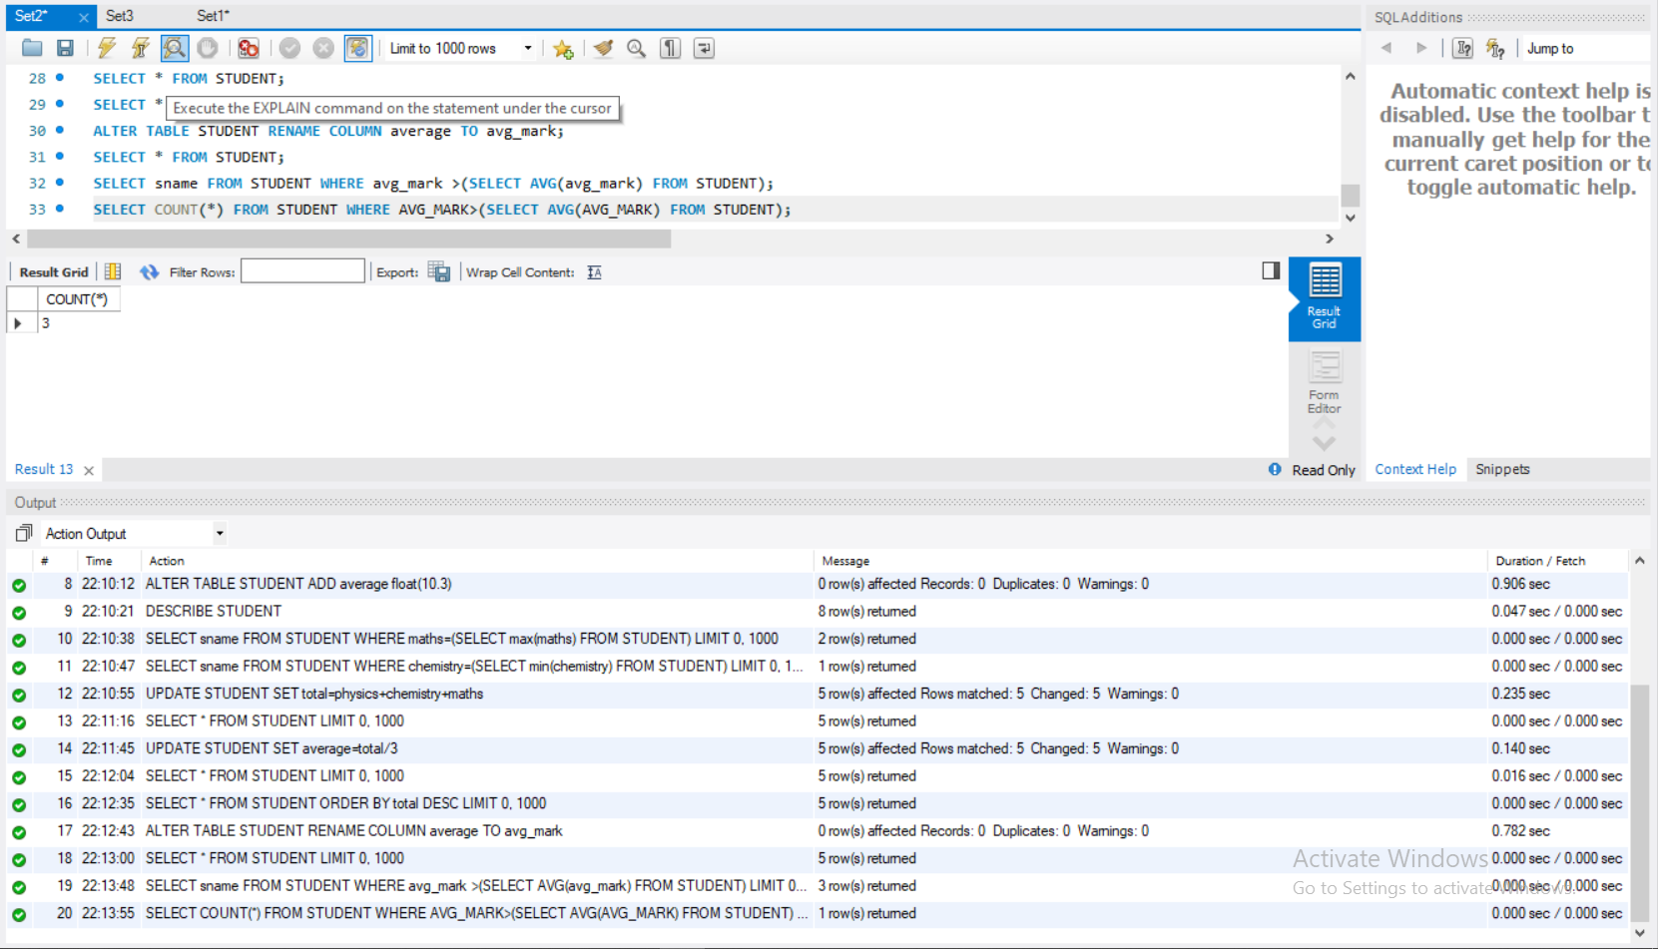

# Q UESTION SET 3

Create the Table LOAN_ACCOUNTS with the structure given below

|  |  |  |
| --- | --- | --- |
| Field Name | Data Type | Length |
| Accno | CHAR | 4 |
| Cust_name | VARCHAR2 | 15 |
| Loan_Amount | NUMBER | 7 digits and 2 decimal places |
| Installments | NUMBER |  |
| int_rate | NUMBER | 2 digits and 2 decimal places |
| Start_date | DATE |  |
| Interest | NUMBER | 7 digits and 2 decimal places |

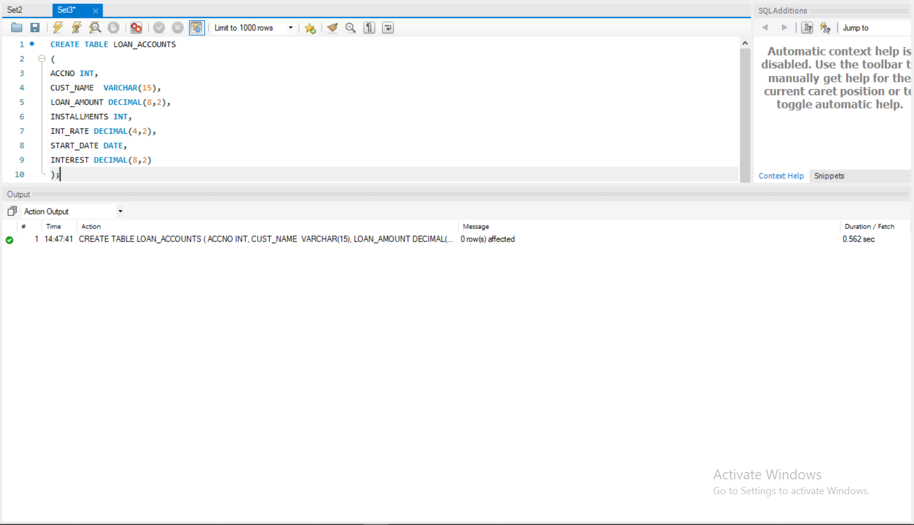

Add another column ‘category’ of type varchar2(1) in the Loan Table

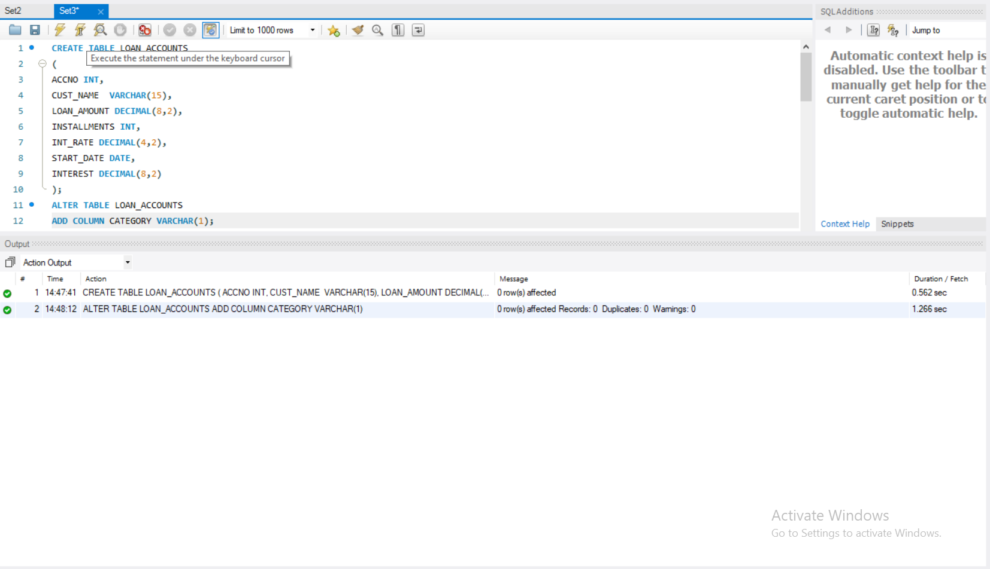

|  |  |  |  |  |  |  |
| --- | --- | --- | --- | --- | --- | --- |
| Accno | Cust_nam e | Loan_Amoun t | Installment s | int_rate | Start_date | Interest |
| 1001 | R.K Gupta | 300,000.00 | 36 | 12.00 | July 19,  2009 |  |
| 1002 | S.P  Sharma | 500,000.00 | 48 | 10.00 | March 22,  2008 |  |
| 1003 | K.P Jain | 300,000.00 | 36 | NULL | August 3,  2007 |  |
| 1004 | M.P  Yadav | 800,000.00 | 60 | 10.00 | June 12,  2008 |  |
| 1005 | S.P Sinha | 200,000.00 | 36 | 12.50 | March 1,  2010 |  |
| 1006 | P. Sharma | 700,000.00 | 60 | 12.50 | May 6,  2008 |  |
| 1007 | K.S Dhall | 500,000.00 | 48 | NULL | May 3,  2008 |  |

Insert the following details into the table

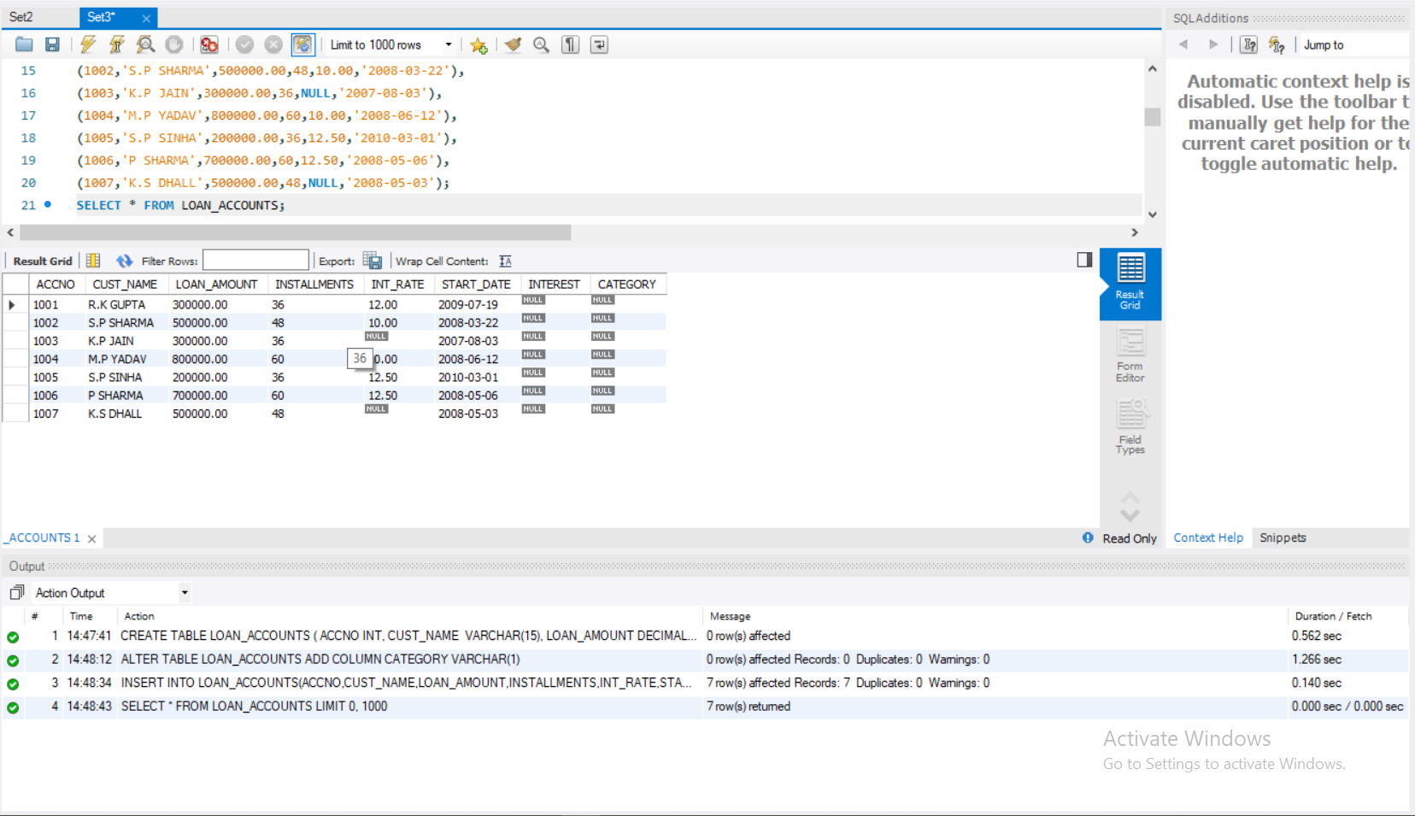

1. Put the interest rate 11.50% for all the loans for which the interest rate is

NULL

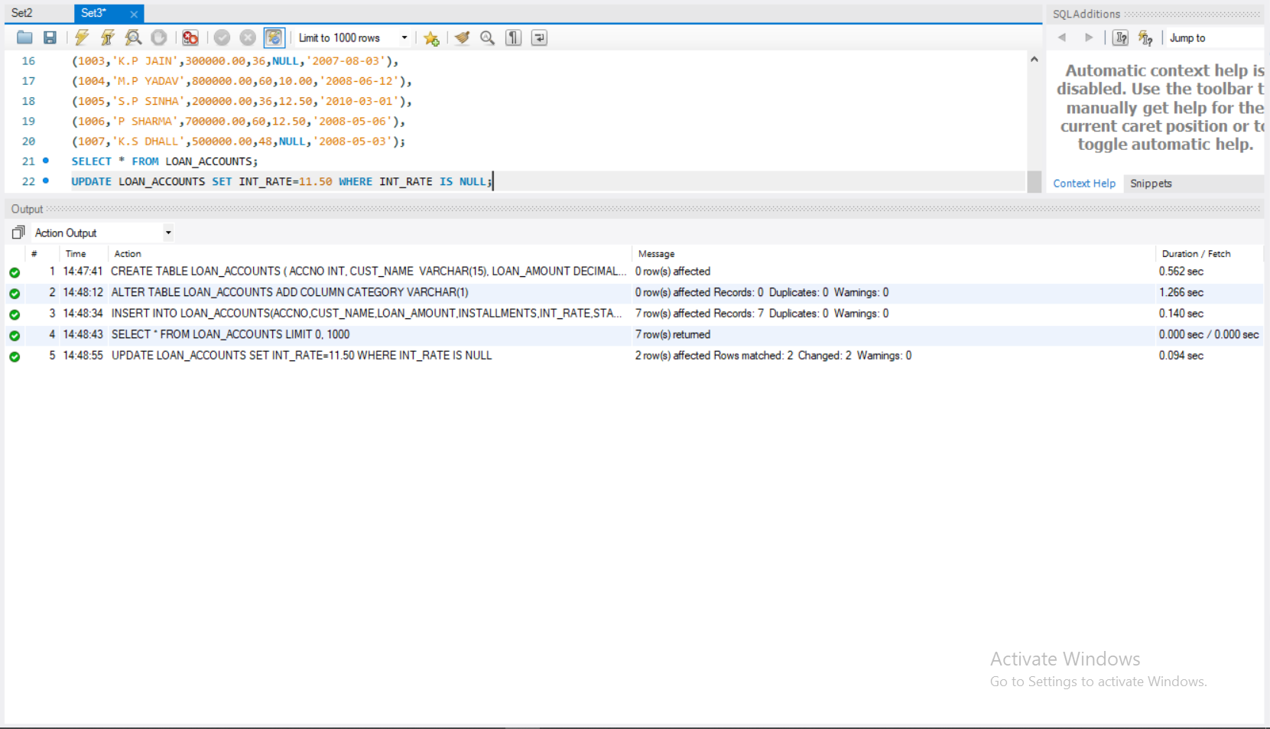

1. Increase the interest rate by 0.5% for all the Loans for which the Loan amount is more than 400000.

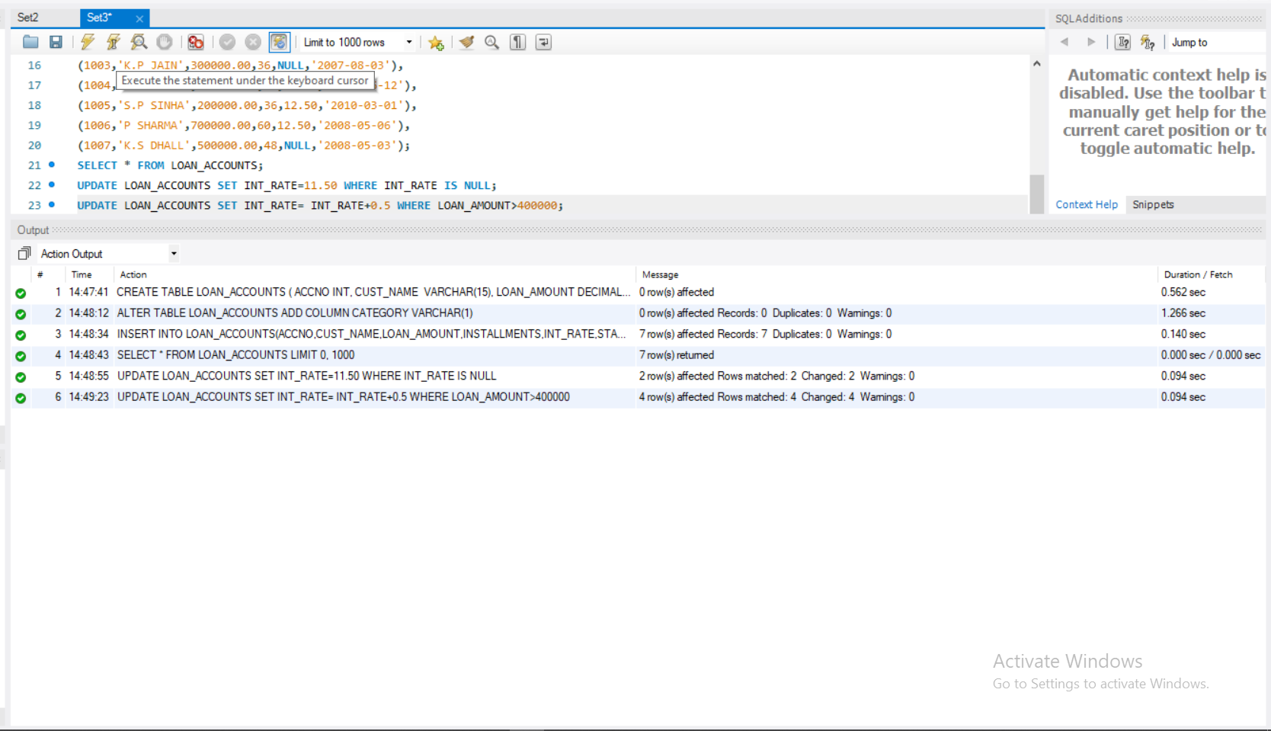

1. For each Loan replace Interest with (Loan_amount * Int_rate* installments)/(12*100).

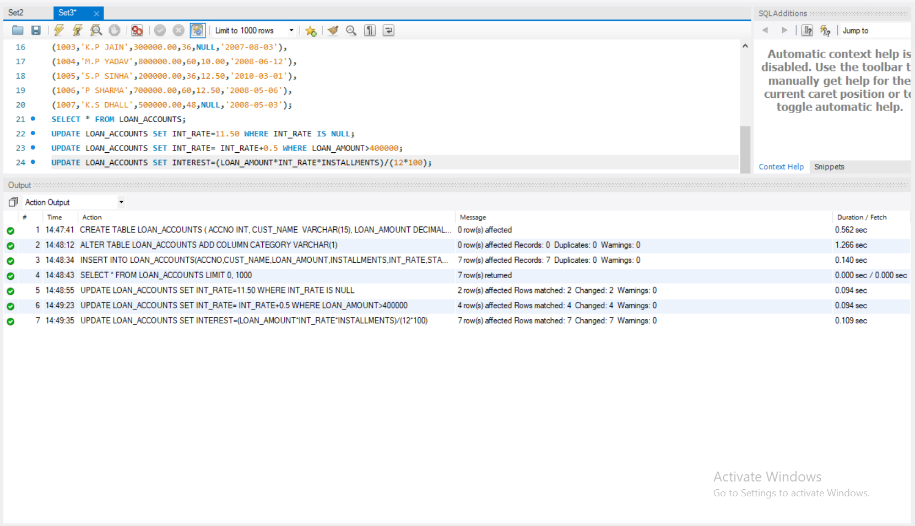

1. Delete the records of all the Loans whose start date is before 2008.

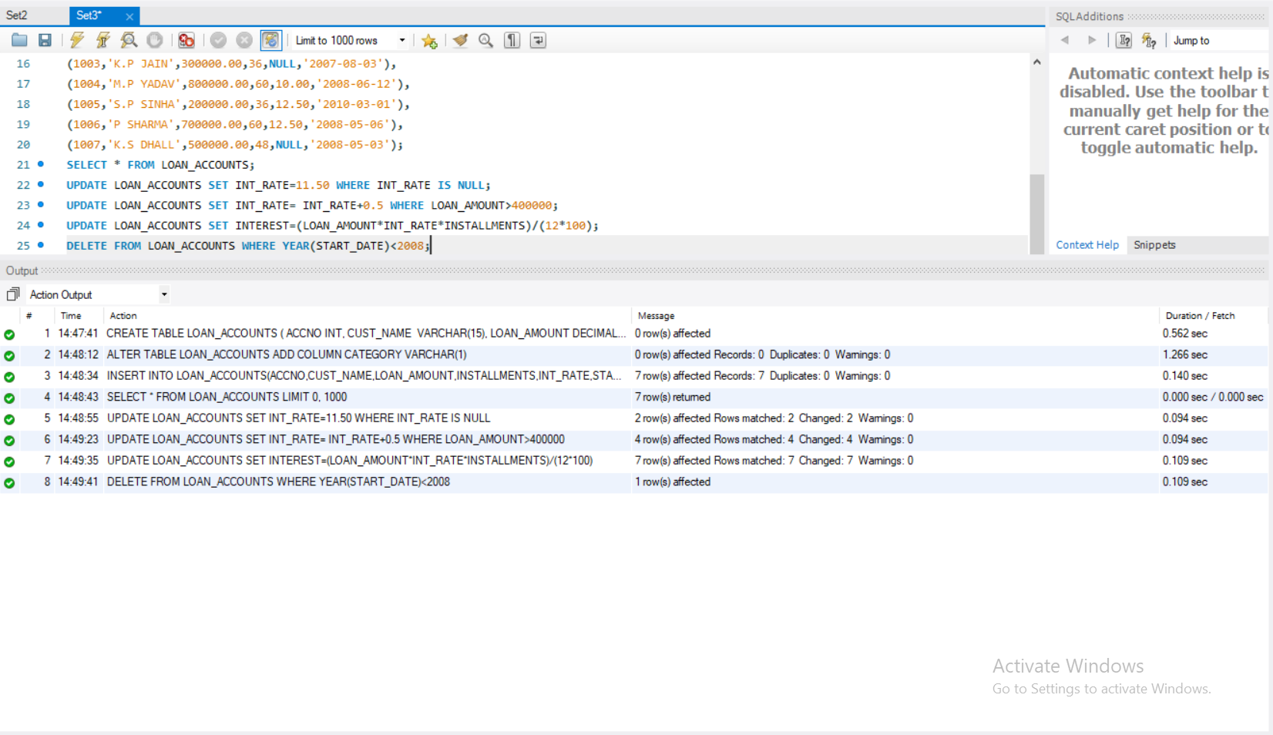

1. Delete the records of all the Loans whose name starts with ‘K’

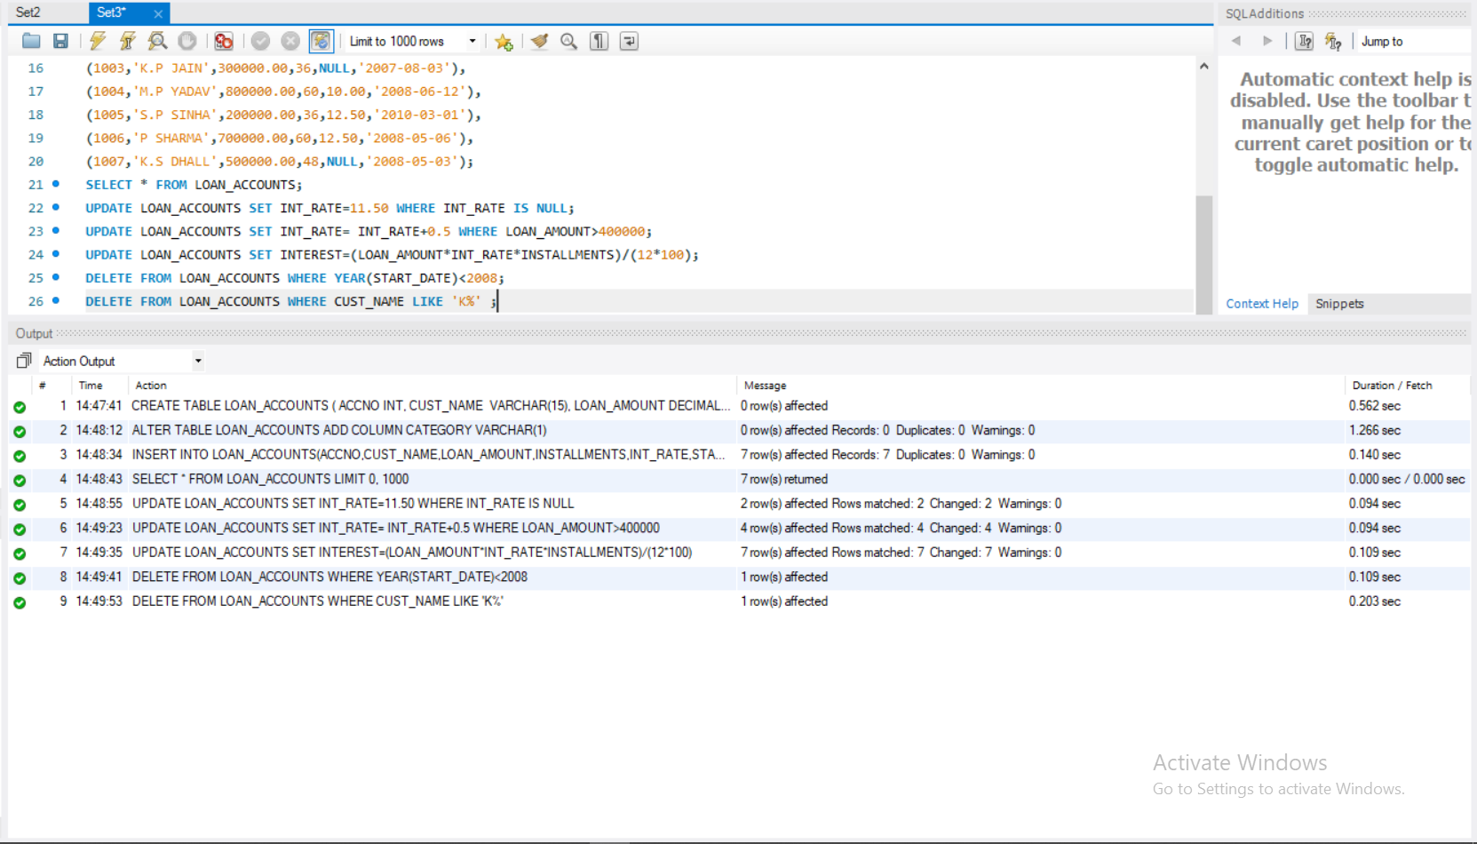

1. Display the details of all the Loans with less than 40 installments.

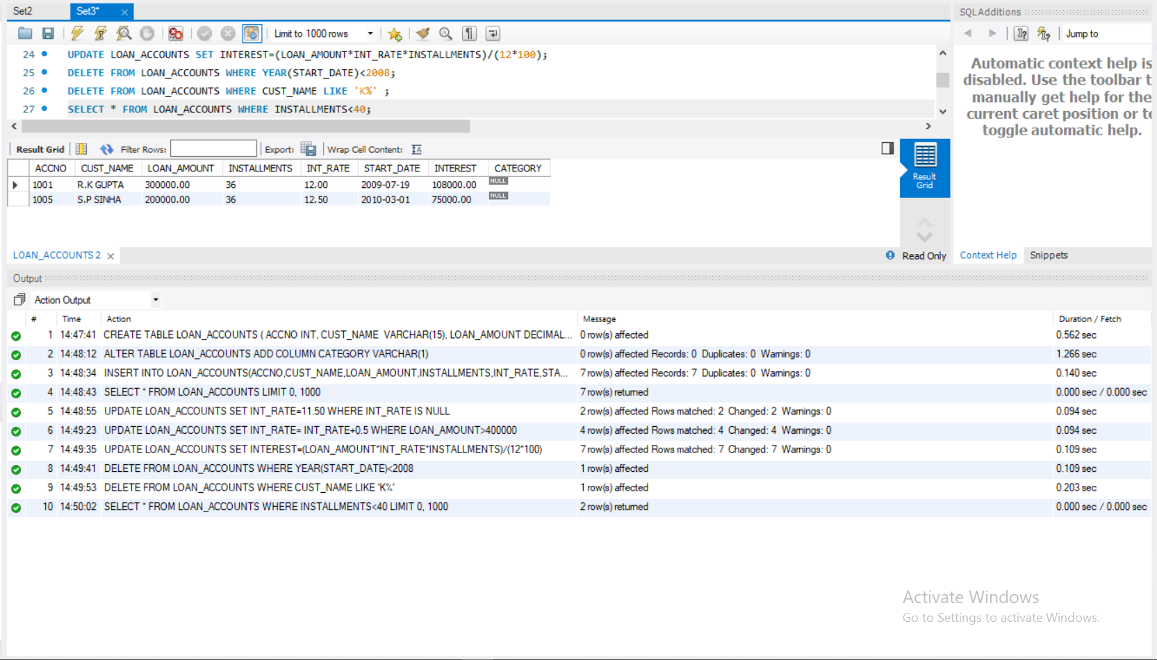

1. Display the Accno and Loan_amount of all the loans started before 01- 04-2009.

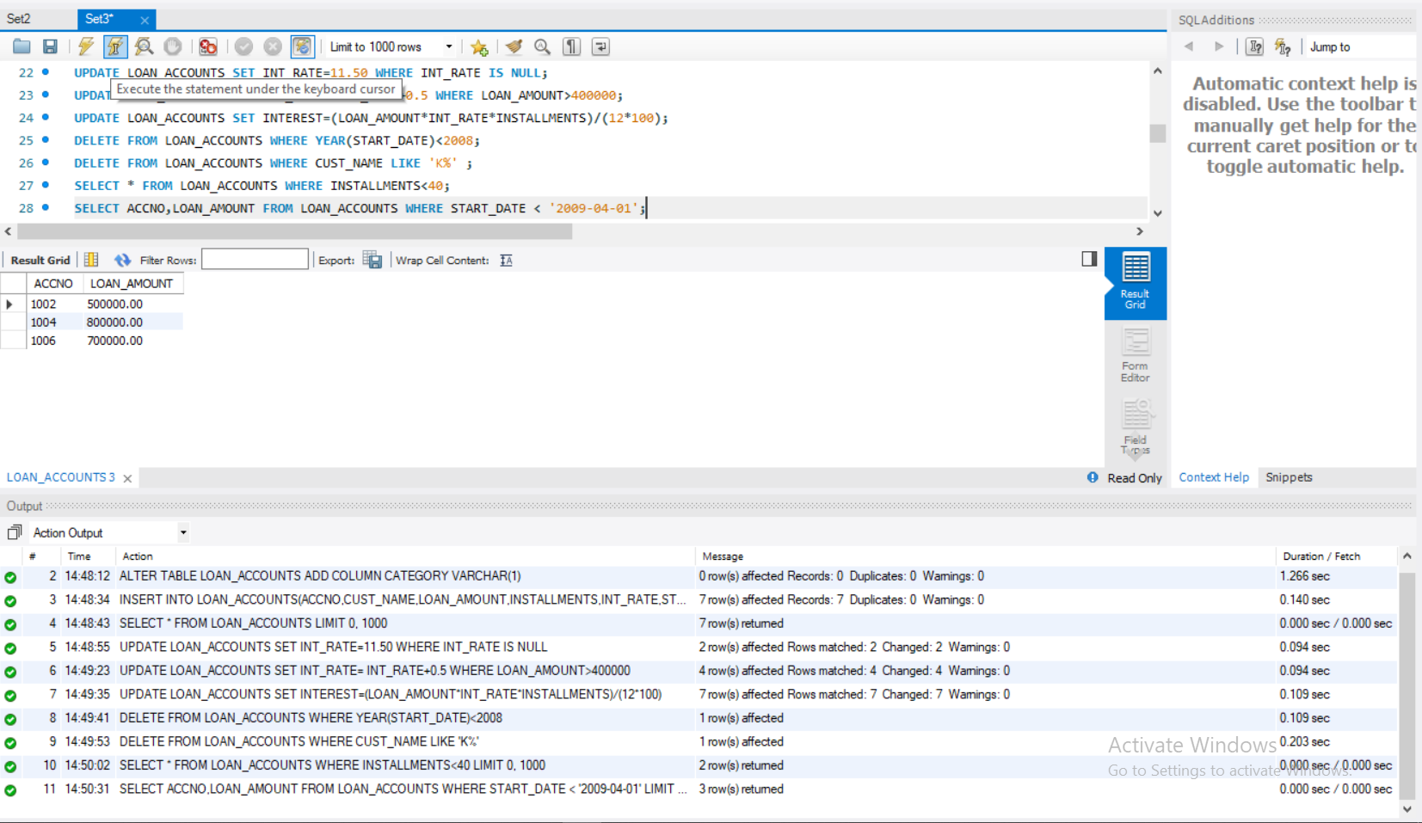

1. Display the int_rate of all Loans started after 01-04-2009.

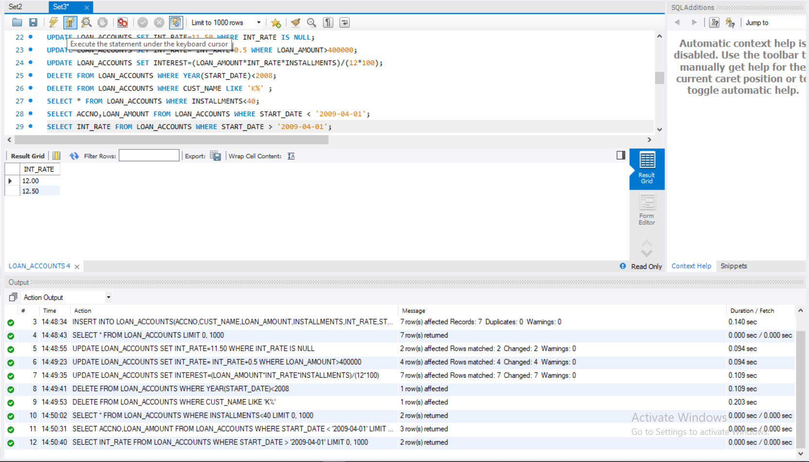

1. Display the Accno, cust_name and Loan amount for all the Loans for which the cust_name ends with‘Sharma’.

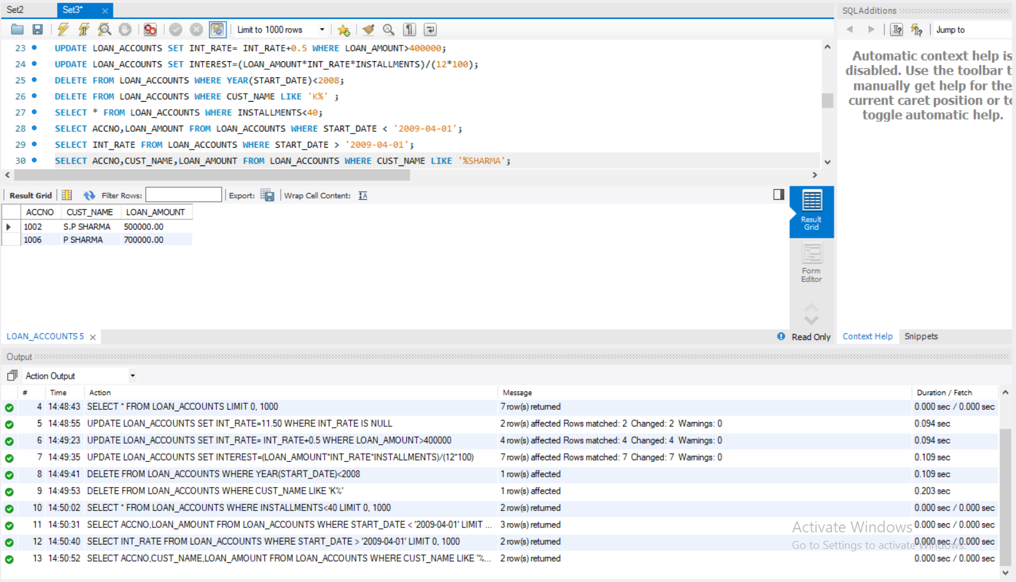

1. Loan_Amount of all the Loans for which the Cust_name ends with ‘a’.

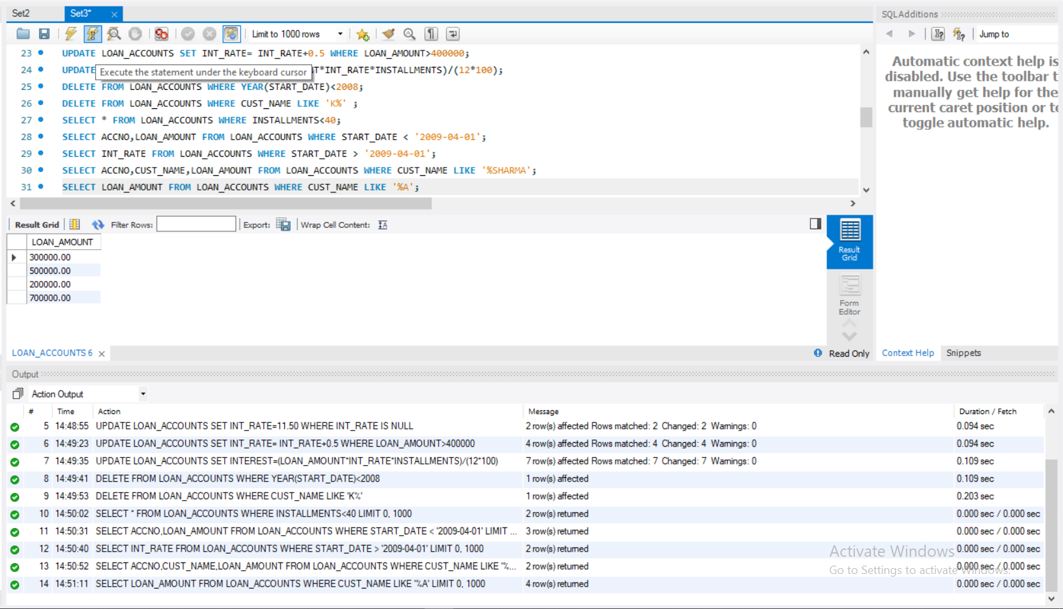

1. Display the Accno, Cust_name and Loan_Amount for the Loans for which the Cust_name contains ‘a’.

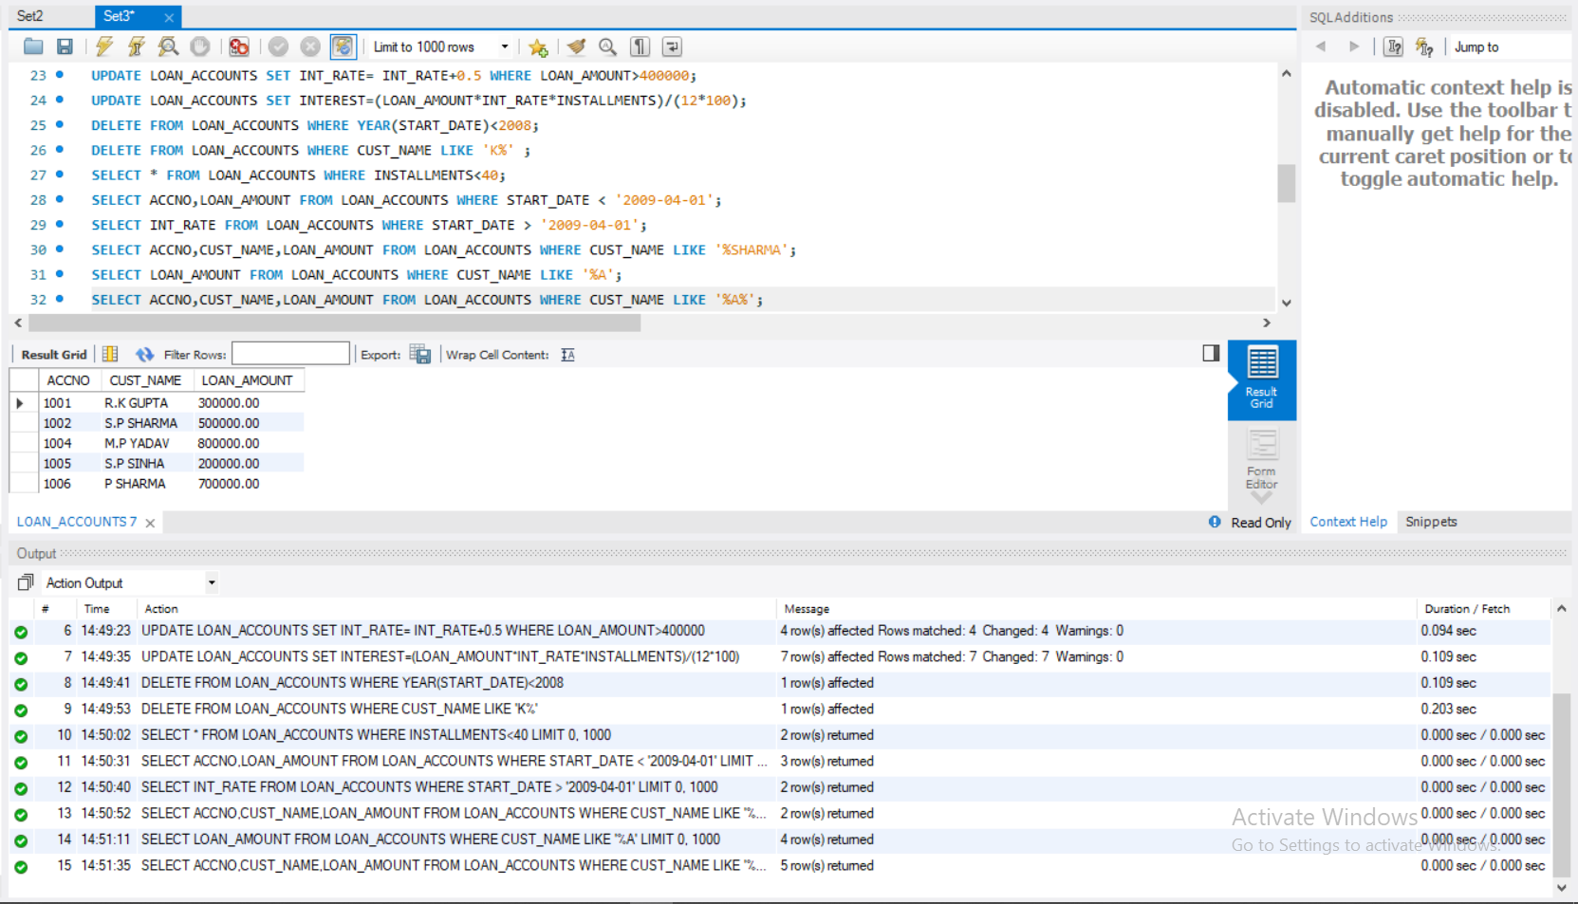

1. Dsiplay the Accno, Cust_name and Loan_Amount for all the Loans for which the Cust_name does not contain ‘P’.

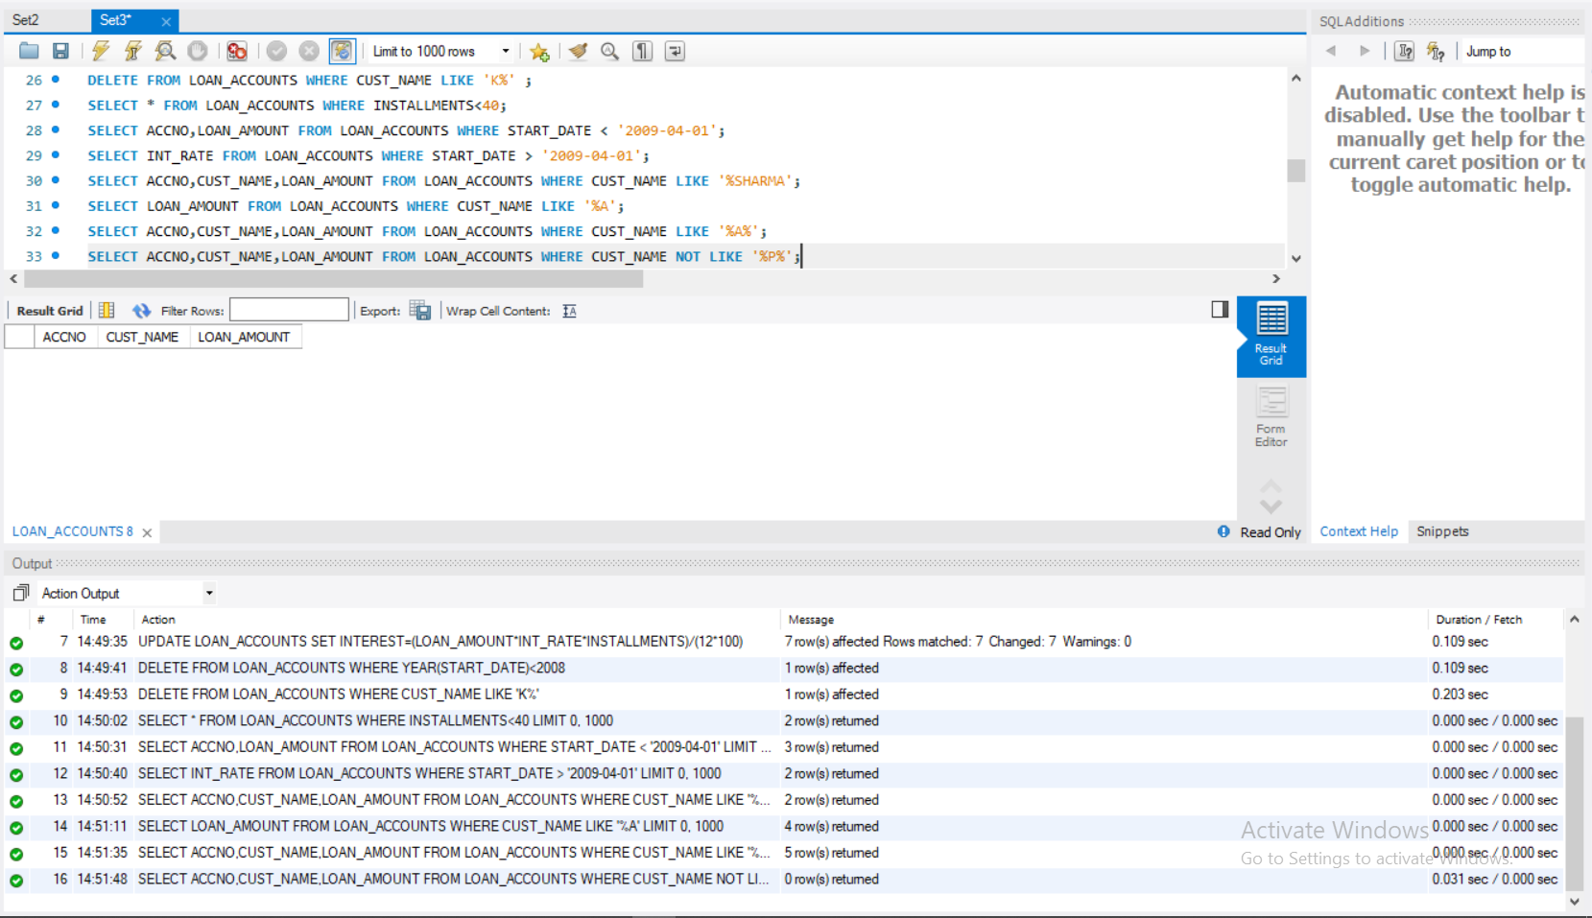

1. Display the structure of table LOAN_ACCOUNTS so that you can verify that the table is created as required.

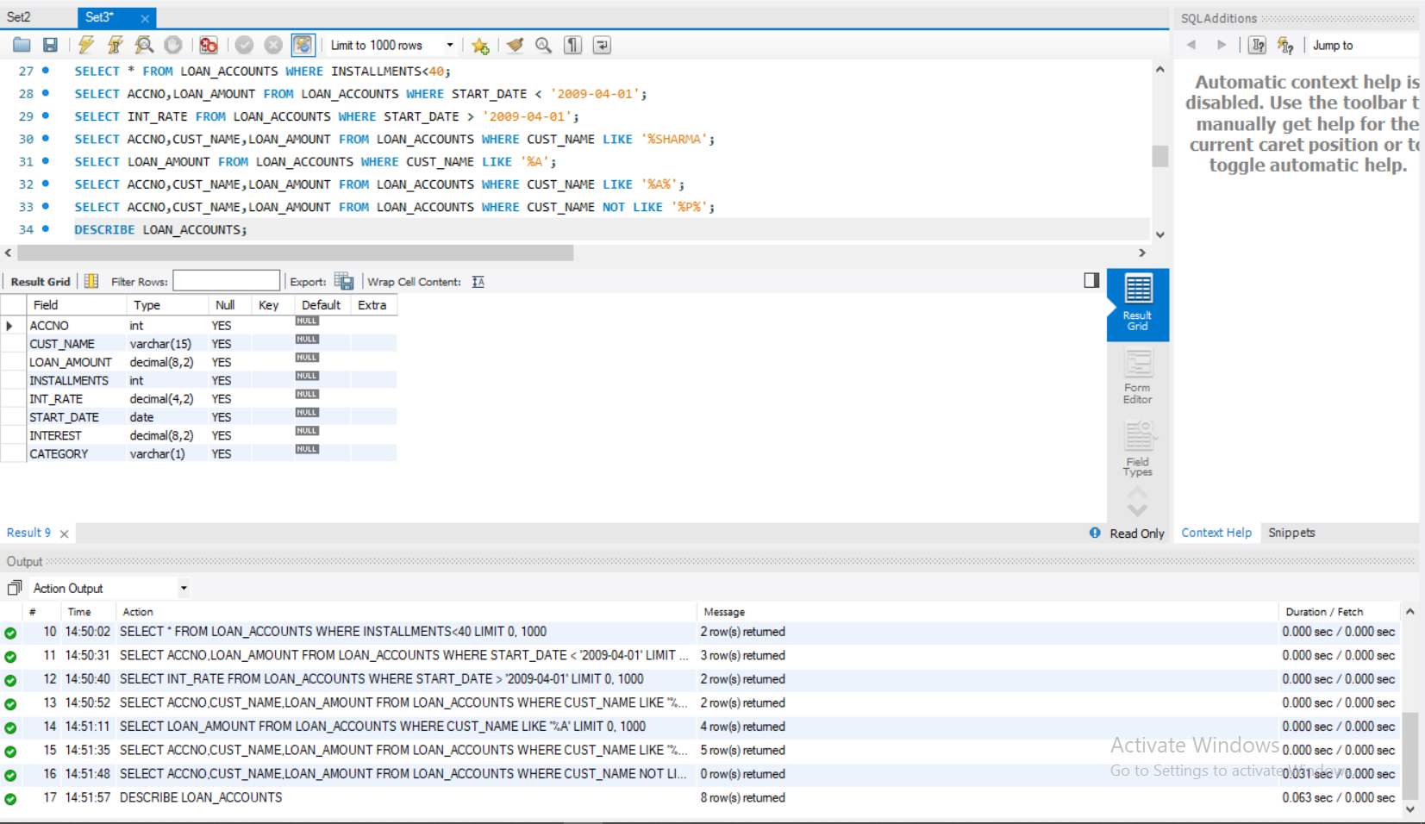

1. Display the details of all the loans in the ascending order of their Loan_Amount.

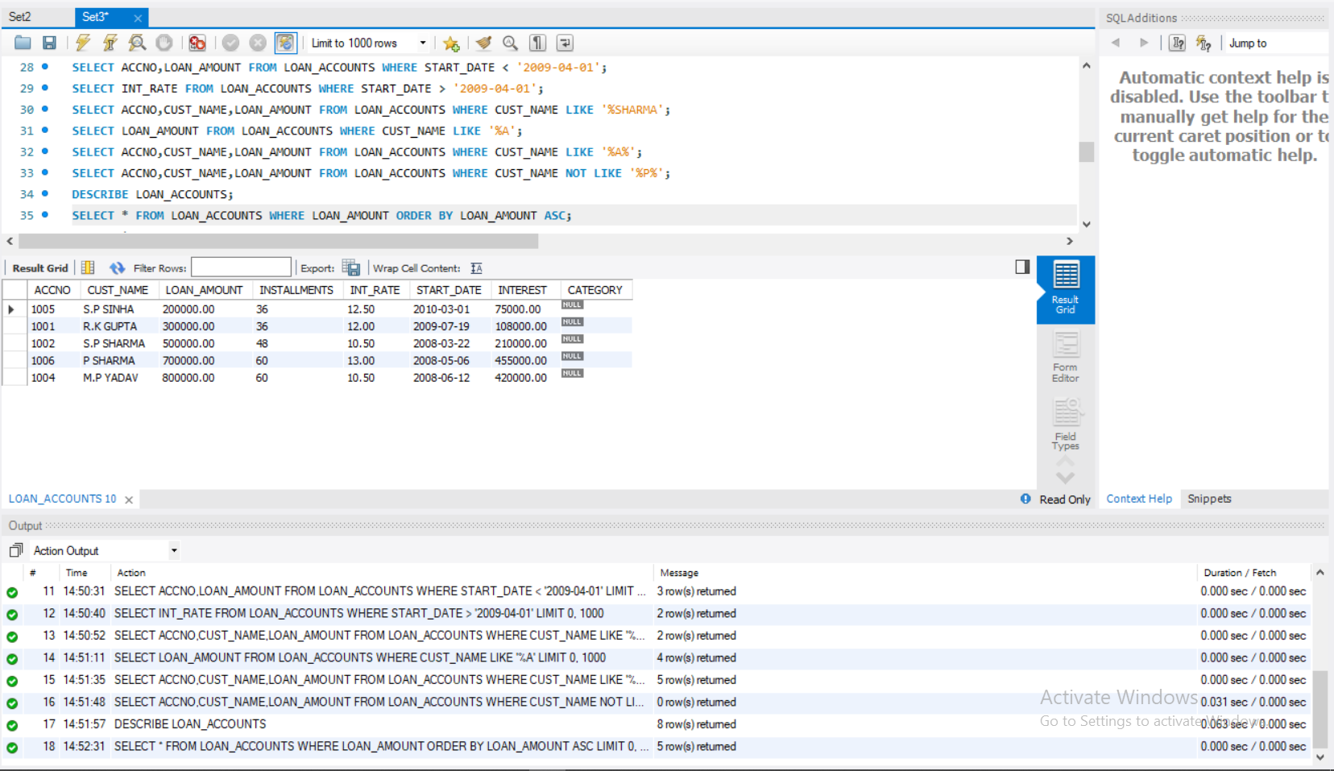

1. Display the details of all the Loans in the descending order of their Start_date.

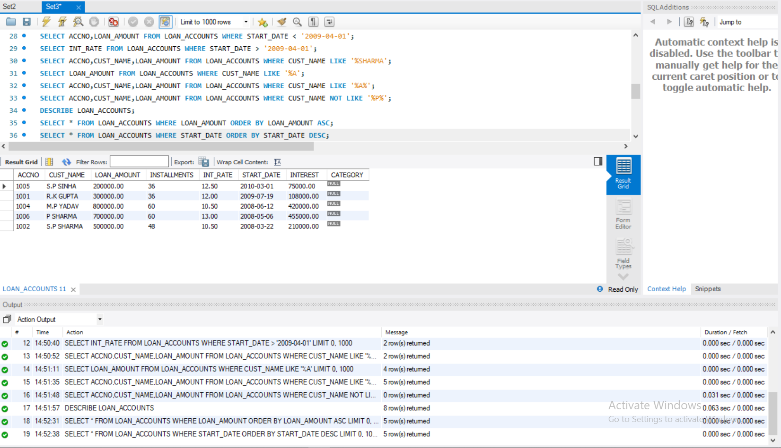

1. Display the details of all the Loans in the ascending order of their Loan_amount and within Loan_amount in the descending order of their Start_date.

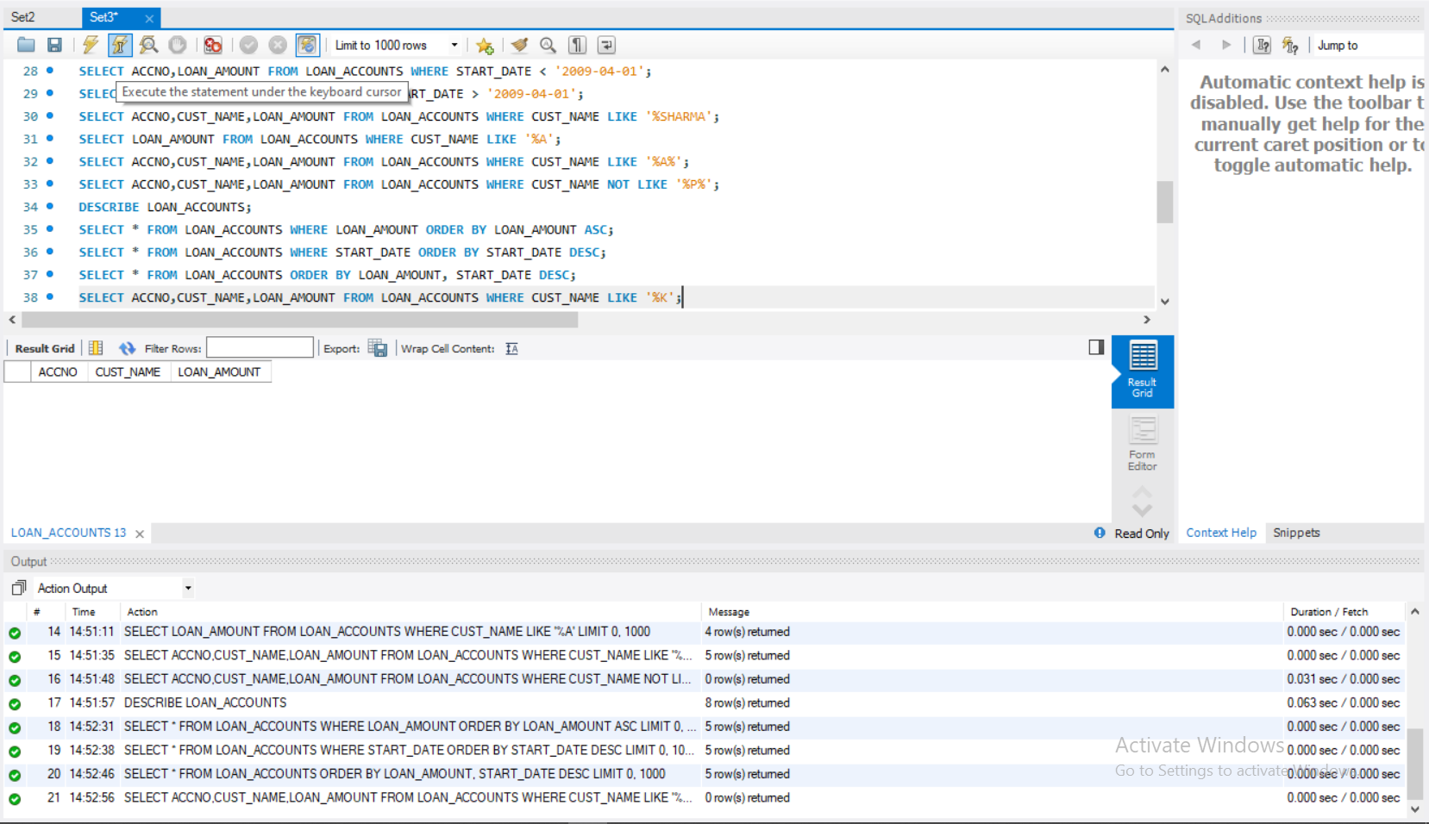

1. Display the Accno, Cust_name and Loan_Amount of all the Loans for which the Cust_name starts with ‘K’.



1. Display the details of all the Loans whose rate of interest in NULL.

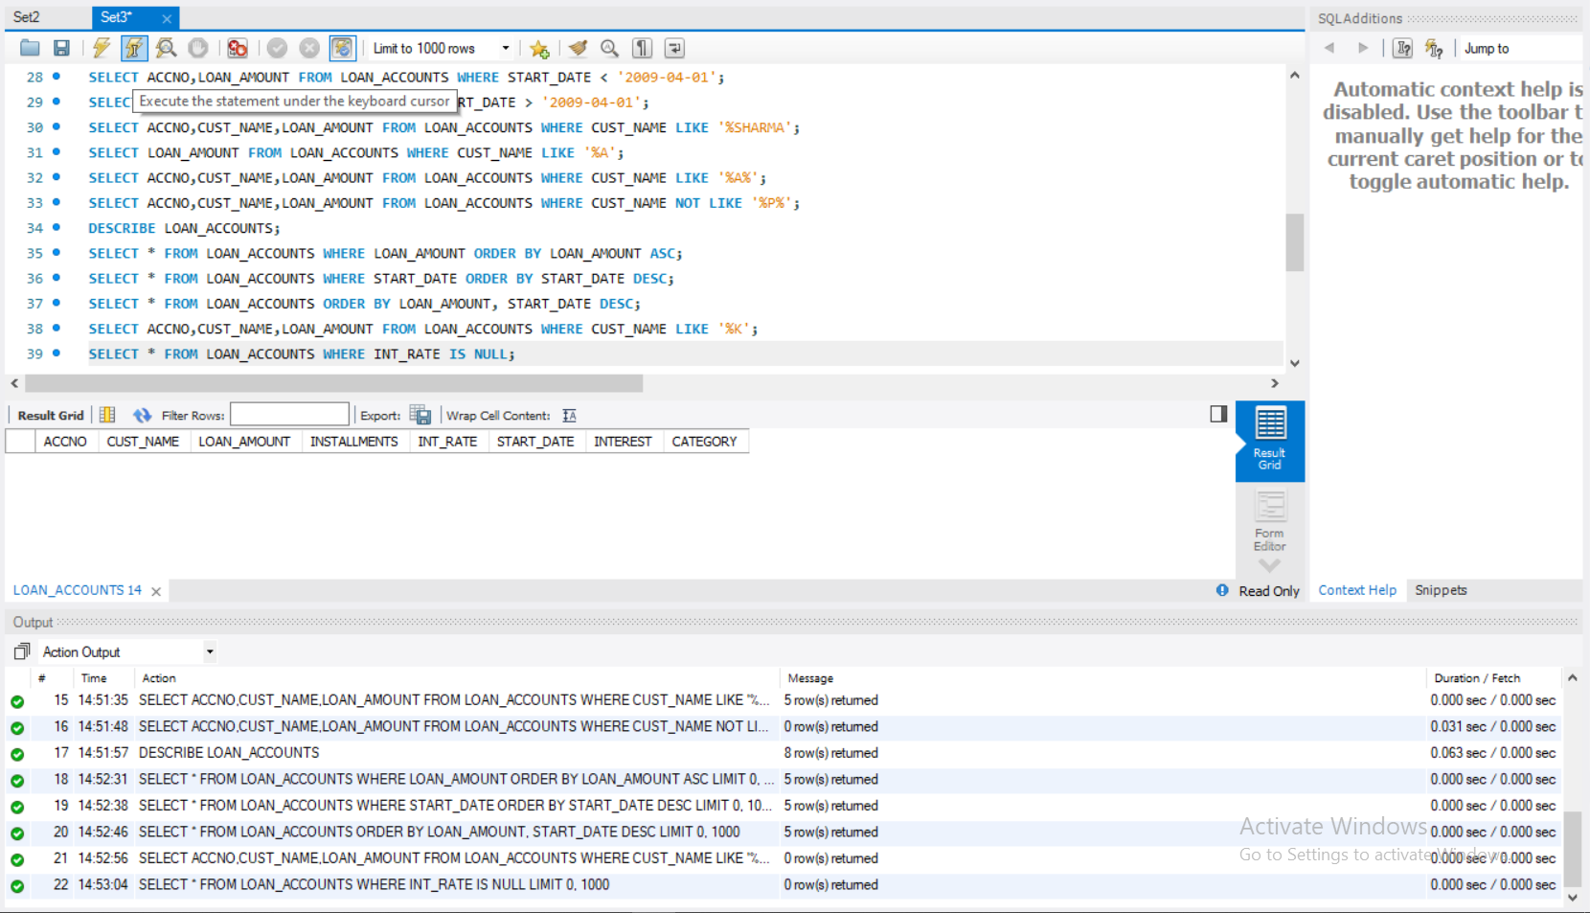

19.Display the details of all the loans whose rate of interest is not NULL.

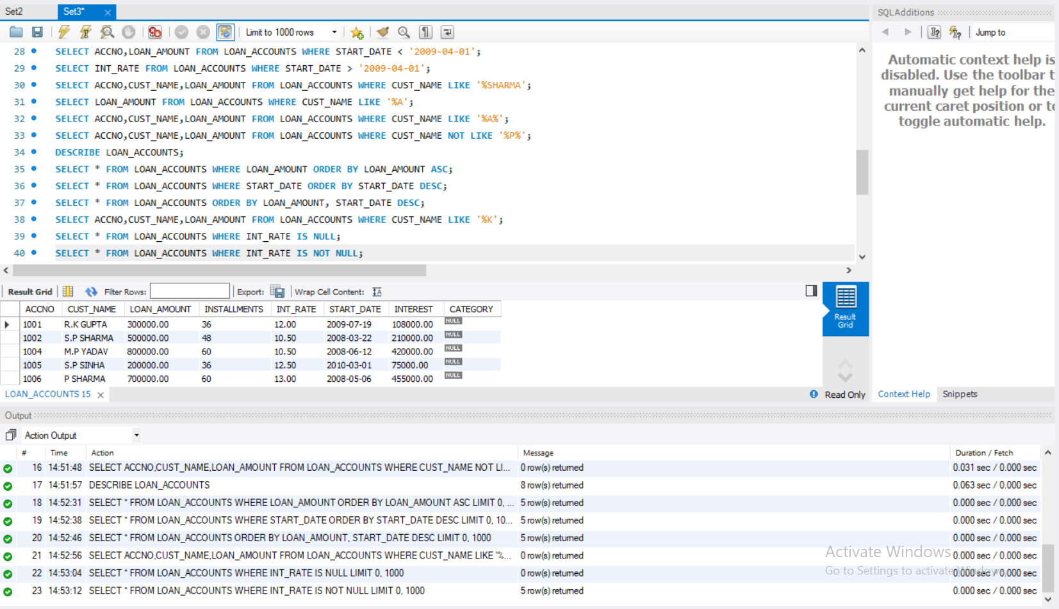

20.Display the amounts of various loans from the table Loan_Accounts. A

Loan_Amount should appear only once.

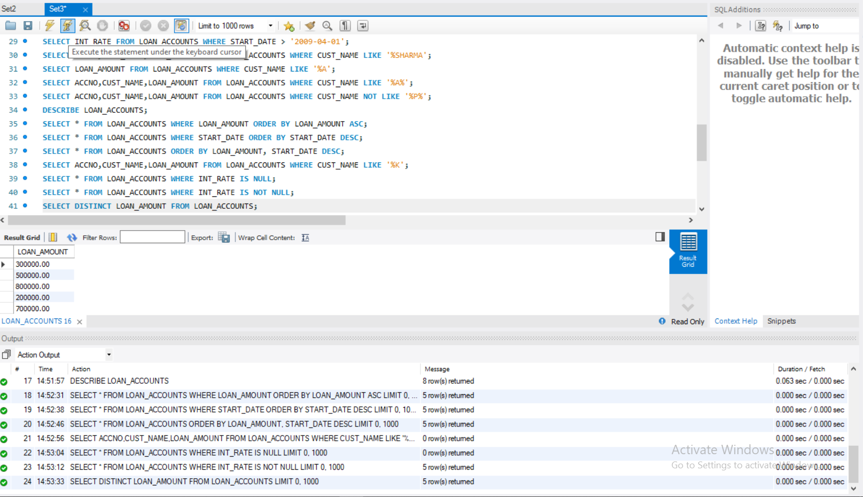

1. Display the details of all the loans started after 31-12-2008 for which the number of installments are more than 36.

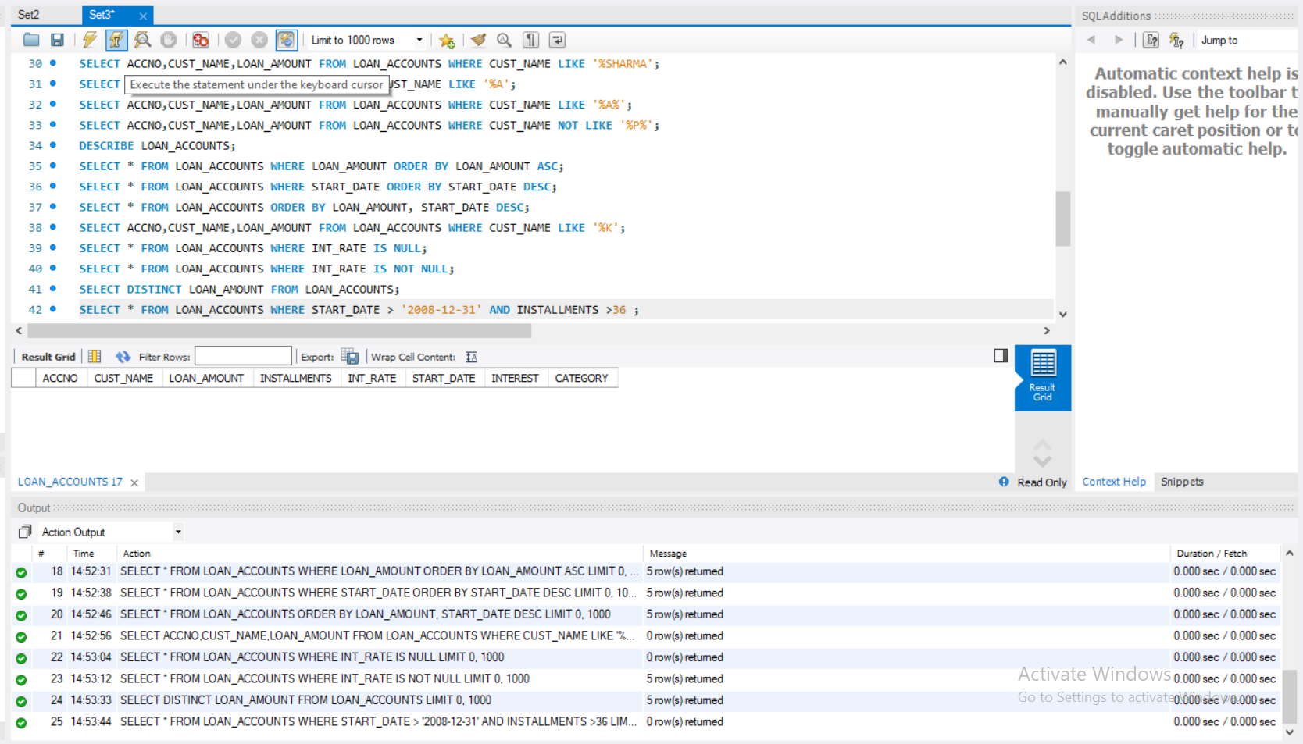

1. Display the Customer_name and Loan_amount for all the Loans for which the Loan amount is less than 500000 or int_rate is more than 12.

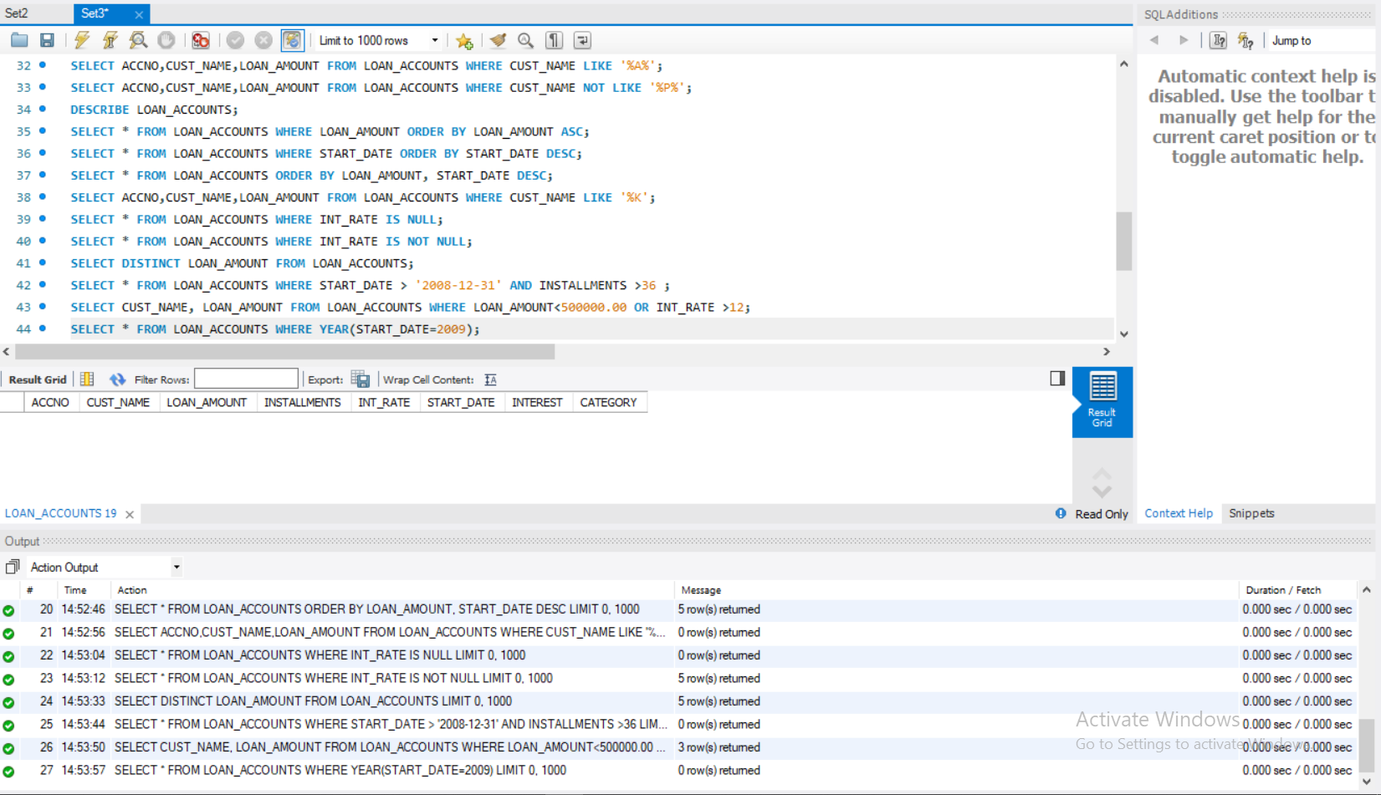

23.Display the details of all Loans which started in the year 2009.



24.Display the details of all the Loans whose Loan amount is in the Range

400000 to 500000.

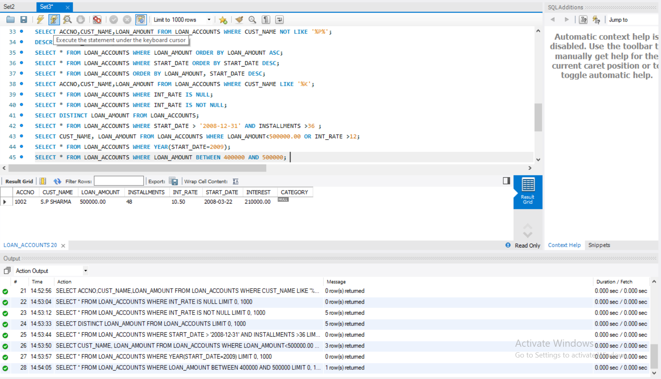

1. Display the Customer_name and Loan_amount of all the Loans for which the number of installments are 26, 36 and 48.

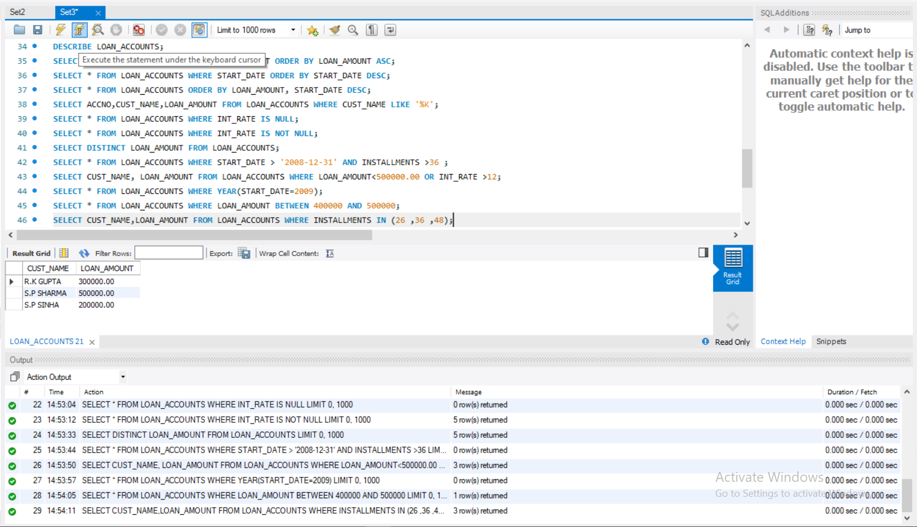

1. Display the customer name, loan_amount and interest rate. If interest rate is NULL, display it as 0.

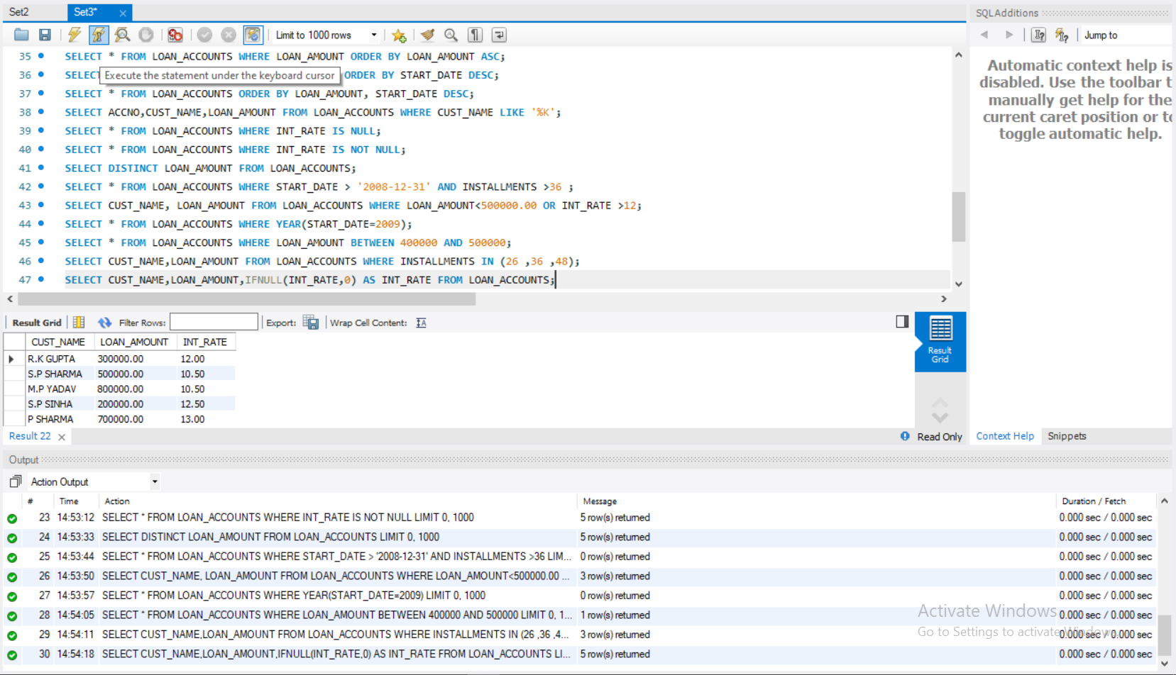

1. Display the customer name, loan_amount and interest rate. If interest rate is NULL, display it as “No Interest”.

